**Class Project 3- Text Analytics**

Introduction to Big Data & Analytics

CSCI 6444

Group 13- Amish Raj, Arham Ashfaq  
Submitted to Professor Stephen Kaisler

**1. Dataset Description**

The dataset is a book called “A Princess of Mars” by Edgar Rice Burroughs. It is text file containing several chapters. For the purpose of this project, we use chapters I-XI.

**2. Objective**

Our objective, through this project is to analyze the large text file “A Princess of Mars” and perform Text analytics on it. Through various methods of analysis, we aim to gain an understanding of the text, the sentiment behind it, and make useful observations.

**3. Loading the Dataset and Creating a Corpus**

We begin our analysis by setting the working directory and loading the dataset.

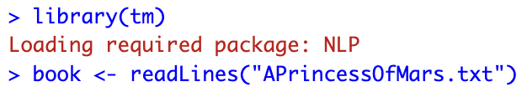

We separate the chapters as we want to create a corpus where each of the eleven chapters (Chapter I-XI) is a document. We identify the indices using the which method as shown below and separate the chapters by the chapter names, e.g., “Chapter I”, and store the values in a variable for each chapter. We can examine the output to verify if we have correctly separated the chapters.

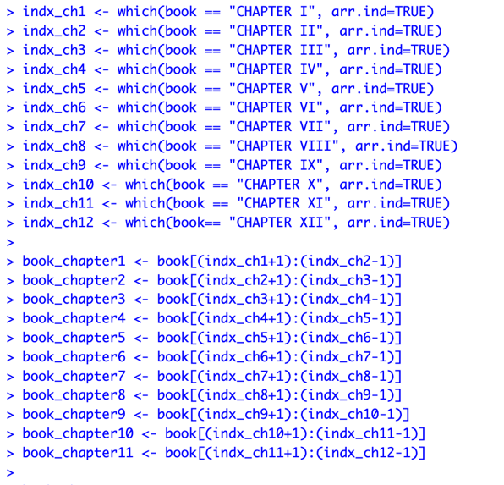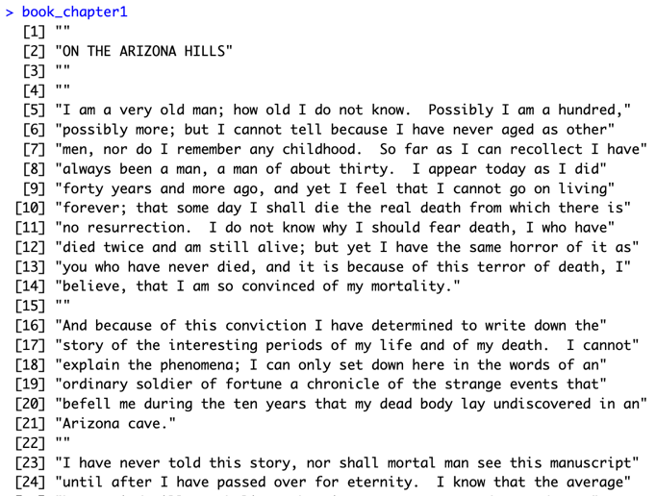

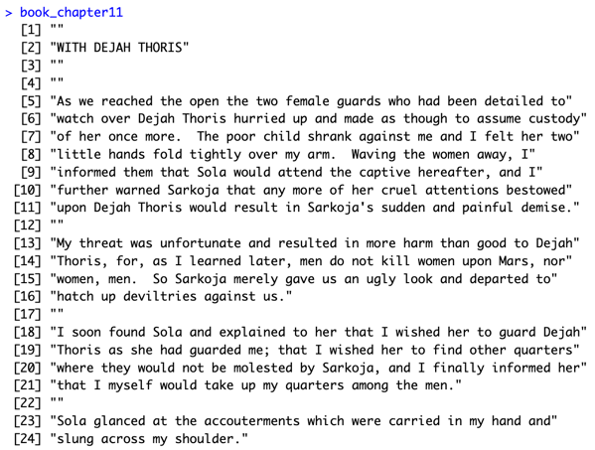

We then proceed to create a directory for the chapters and write each chapter to a text file.

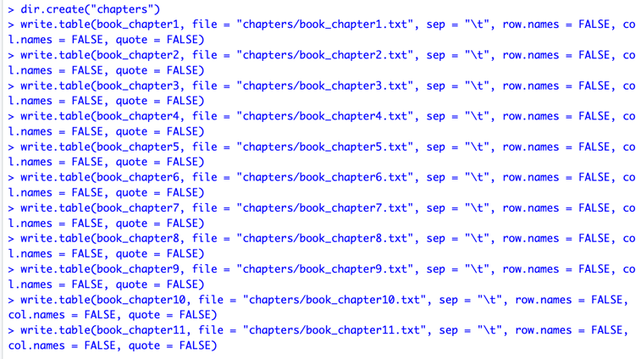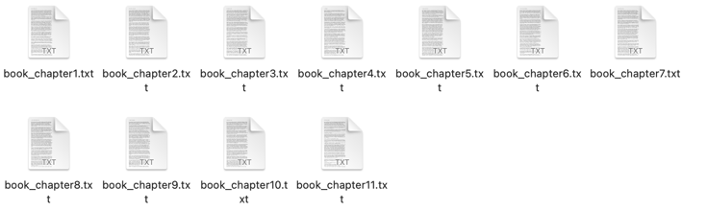

Once our chapters are separated, we can proceed to create a VCorpus. We utlize the VCorpus() method from the “tm” package to create our corpus and store the corpus in “POM”. The structure can then be examined using the str() method.

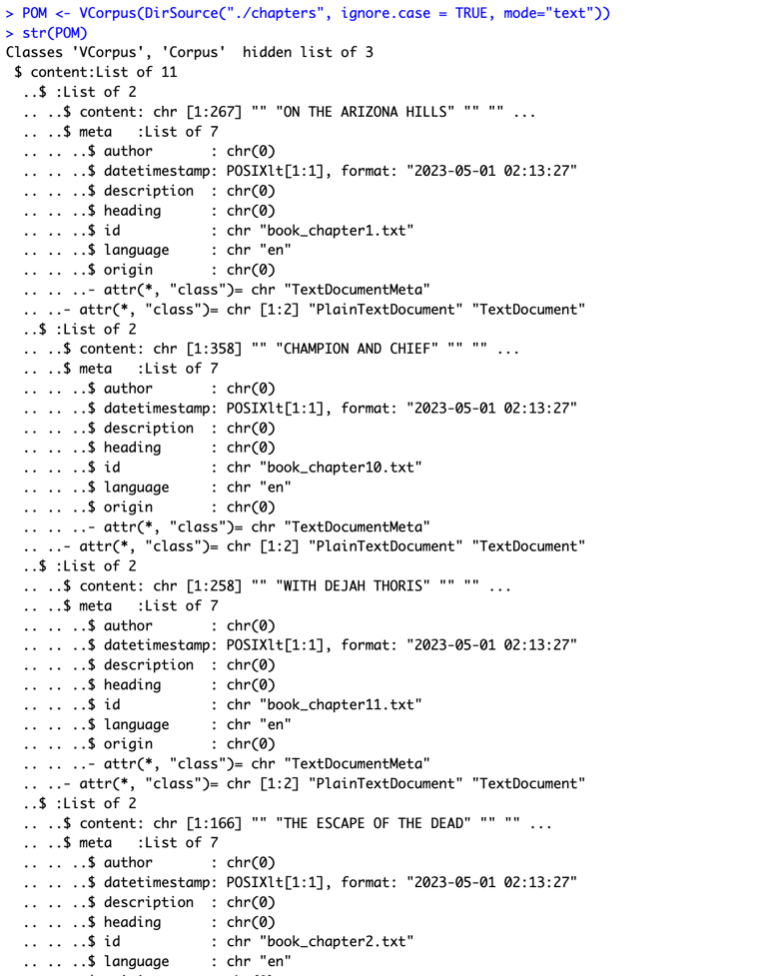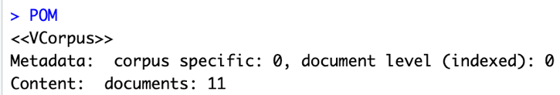

Here, we can see that we have a corpus of 11 documents each representing a chapter and where content represents the text they contain, each having about 160-400 characters. We can also look some other parameters such as meta which contains the metadata of the documents (we haven’t specified the author, heading, etc. so those fields appear empty).

If we want to extract text, we can do so in the following manner, as per the rubric. The first document contains 13962 characters. Several lines below have been omitted.

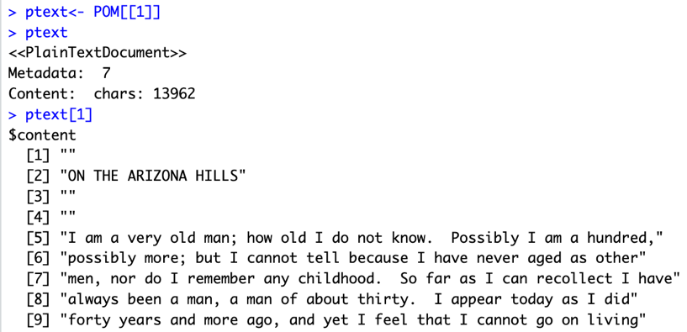

The next step is to create initial Document Term Matrices (DTM). Each row represents a document and each column represents a term in the document. This is helpful as we can analyze our data with vector and matrix algebra. Similarly, we also create a Term Document Matrix (TDM) where rows represent terms and columns represent documents. These are shown below, utilizing the DocumentTermMatrix() and the TermDocumentMatrix() methods from the “tm” package.

Document Term Matrix:

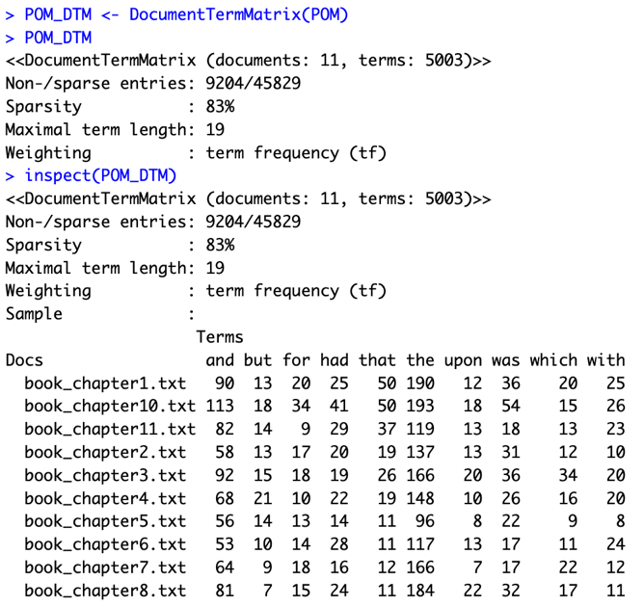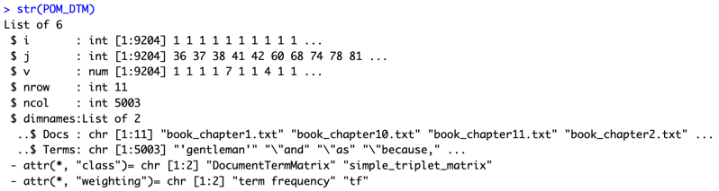

Examining the DTM, we can notice the 11 rows each representing a chapter, and 5003 terms in total. The maximal term length is 19 and the Sample field gives us a glimpse of the Document Term Matrix. We notice a high sparsity of 83% meaning that there are more terms with 0s in the matrix. This is expected as the corpus is big and not every term would be found in each document.

Term Document Matrix:

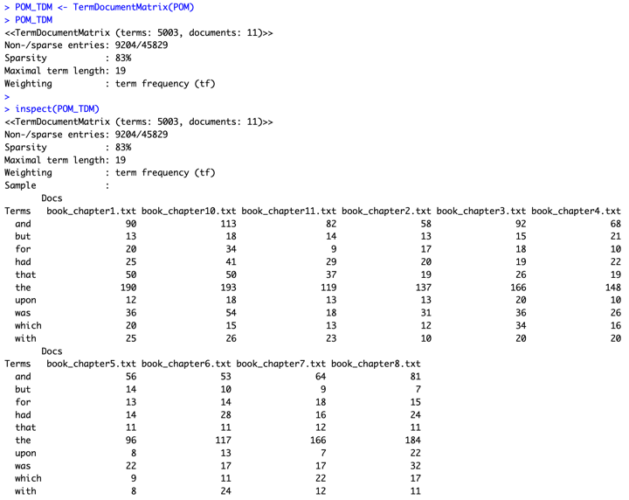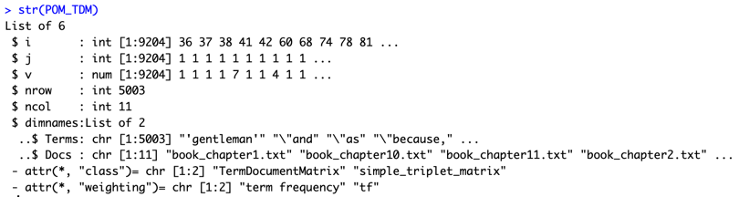

The Term Document Matrix gives us similar information in a different matrix.

**4. Finding the 10 longest words and sentences in each chapter**

Before we cleanse our corpus and remove stopwords, punctuation, etc. we find the 10 longest words and 10 longest sentences in each chapter. We also found the 10 longest words and sentences in all the chapters.

To do this, we utilize the tibbles package that helps us create data frames. To do this, we need to convert the corpus we have into a tibbles data structure. We start by installing the packages “dplyr”, “tidytext”, and “ggplot2” and making them libraries in our project.

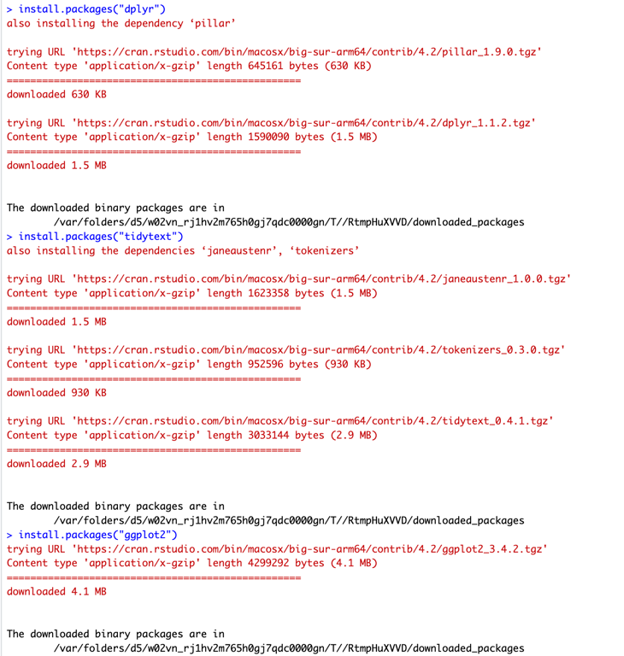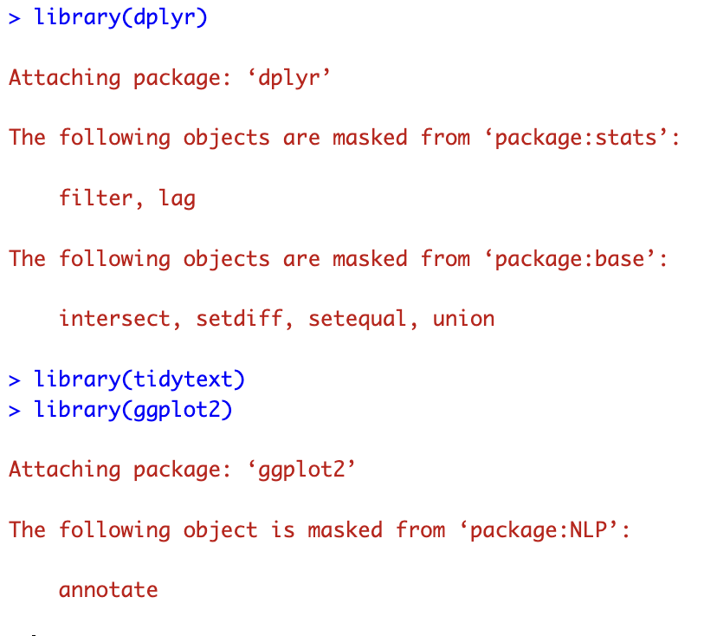

Once our libraries have been imported, we convert our corpus “POM” into a tidy Corpus as follows.

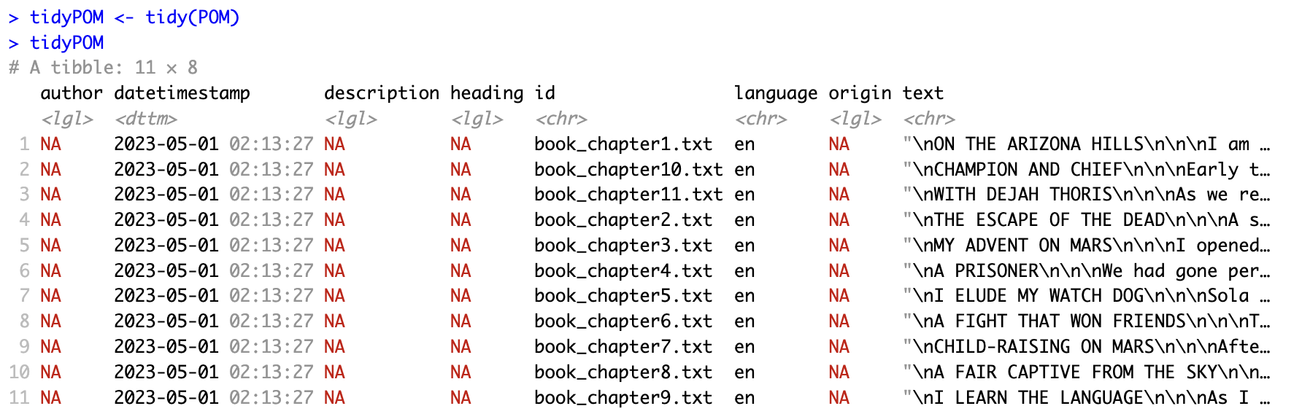

We can see our tidy corpus contains the metadata we examined earlier along with the text in each document. This is useful in performing our analysis of the 10 longest words and sentences.

First, we compute the 10 longest words and sentences in all the chapters. We do this by tokenizing the words and producing a tibble as follows. The words are stored in POMWords.



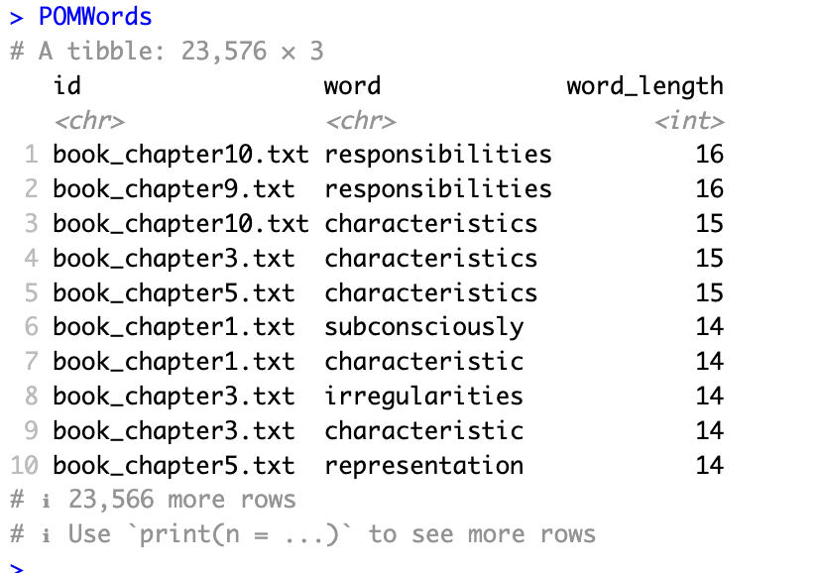

We can see the 10 longest words in all the chapters, highest being the word “responsibilities” with a length of 16 characters, and the 10th word “representation” has 14 characters. Similarly, by modifying the unnest_tokens() method, we obtain the 10 longest sentences in all the chapters.

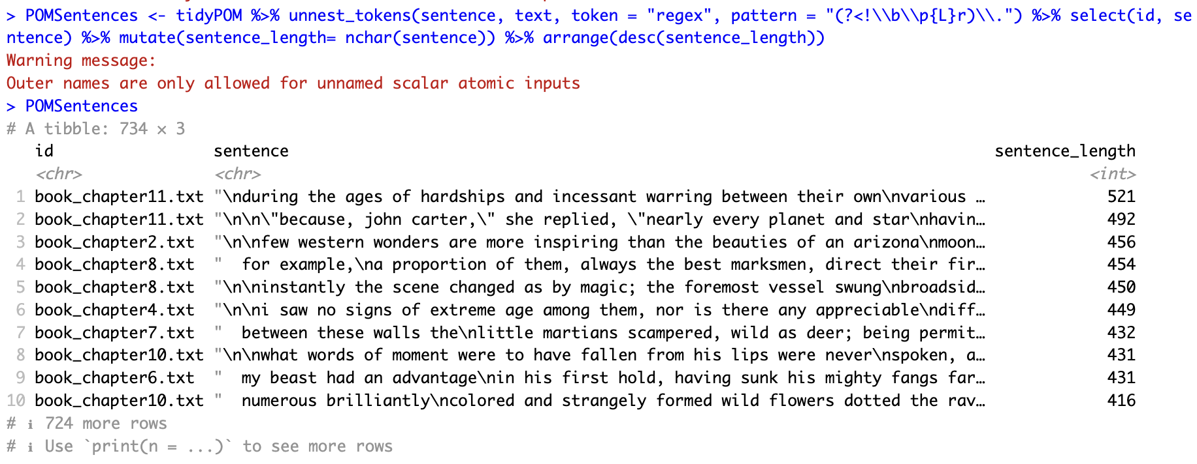

The regular expression above uses ‘.’as a delimiter for identifying the longest sentences, assuming the period symbol is not preceded by any ‘r’ ending titles like, Dr., Mr. etc. This regular expression helps correctly split the text into sentences.

We can see the longest sentence in the chapter 11 having a length of 521 characters and the 10th sentence from chapter 10 has 416 characters.

Next we compute the 10 longest words and sentences for all the chapters. We follow the same procedure except we generate a tidy corpus for each chapter using the tidy() method and then compute the 10 longest words and sentences. These results have been compiled into a table as follows, and the screenshots of the same have been attached in the following pages for reference. The screenshots display the length of the longest words and sentences found.

10 Longest Words in each chapter:

|  |  |  |  |  |  |  |  |  |  |  |  |
| --- | --- | --- | --- | --- | --- | --- | --- | --- | --- | --- | --- |
|  | **Chapter 1** | **Chapter 2** | **Chapter 3** | **Chapter 4** | **Chapter 5** | **Chapter 6** | **Chapter 7** | **Chapter 8** | **Chapter 9** | **Chapter 10** | **Chapter 11** |
| **1** | Subconsciously | Contemplation | Characteristics | Circumstances | Characteristics | overwhelmingly | Representative | Reinforcements | Responsibilities | Responsibilities | Accouterments |
| **2** | Characteristic | Metamorphosis | Irregularities | Consideration | Representation | Accomplishing | Conversations | Simultaneously | Expressionless | Characteristics | Circumstances |
| **3** | Understanding | Particularly | Characteristic | Manifestation | Ministrations | Gesticulated | Unnecessarily | circumstances | Unintelligible | Companionship | Questioningly |
| **4** | comparatively | Predicaments | Consciousness | Consideration | Uncomfortable | Intermediary | Intentionally | Southeasterly | Administration | Manifestation | Eavesdropping |
| **5** | sensitiveness | Interruption | Independently | Therapeutics | Intellectual | Transcending | Circumstances | Requisitioned | Accouterments | Ludicrousness | Comparatively |
| **6** | Consternation | Overstrained | Accouterments | Scintillated | Intelligence | Commencement | Intellectual | Southwesterly | Importunities | Precipitately | Intermarrying |
| **7** | Perpendicular | Bewilderment | Noiselessness | Introduction | Straightaway | Executioner | Conversation | Unaccountably | Possibilities | Authoritative | Irretrievably |
| **8** | Resuscitation | Surroundings | gesticulating | Instructions | considerable | Momentarily | Satisfaction | hallucination | Satisfactory | Understanding | Architecture |
| **9** | Comparatively | Unfathomable | Comparatively | Observation | Monstrosity | Perceptibly | Appropriated | Majestically | Manufactured | Theoretically | Compositions |
| **10** | resurrection | crystallized | interminable | immediately | voluntarily | momentarily | humanitarian | irresistible | intelligence | companionship | conversation |

10 Longest Sentences in each chapter:

|  |  |  |  |  |  |  |  |  |  |  |  |
| --- | --- | --- | --- | --- | --- | --- | --- | --- | --- | --- | --- |
|  | **Chapter 1** | **Chapter 2** | **Chapter 3** | **Chapter 4** | **Chapter 5** | **Chapter 6** | **Chapter 7** | **Chapter 8** | **Chapter 9** | **Chapter 10** | **Chapter 11** |
| **1** | however, i\nam not prone to sensitiveness, and the following of a sense of duty | \n\nfew western wonders are more inspiring than the beauties of an arizona\nmoonl | the throwing down of his weapons and the\nwithdrawing of his troop before his a… | \n\ni saw no signs of extreme age among them, nor is there any appreciable\ndiffe… | the nights are either brilliantly illumined or\nvery dark, for if neither of th… | my beast had an advantage\nin his first hold, having sunk his mighty fangs far … | between these walls the\nlittle martians scampered, wild as deer; being permitt… | for example,\na proportion of them, always the best marksmen, direct their fire… | oh, it is one continual, awful period of bloodshed from\nthe time we break the … | \n\nwhat words of moment were to have fallen from his lips were never\nspoken, a… | \nduring the ages of hardships and incessant warring between their own\nvarious … |
| **2** | the fact that it\nis difficult to aim anything but imprecations accurately by m… | i reasoned with\nmyself that i had lain helpless for many hours within the cave… | he sat his mount as we\nsit a horse, grasping the animal's barrel with his lowe… | they first repeated\nthe word \"sak\" a number of times, and then tars tarkas m… | \n\nthis last device produces an intensely brilliant far-reaching white\nlight, b… | \n\ni am ever willing to stand and fight when the odds are not too\noverwhelmingl… | \nchild-raising on mars\n\n\nafter a breakfast, which was an exact replica of the… | \n\ninstantly the scene changed as by magic; the foremost vessel swung\nbroadside… | with this added incentive i nearly drove sola distracted by\nmy importunities t… | numerous brilliantly\ncolored and strangely formed wild flowers dotted the rav… | \n\n\"because, john carter,\" she replied, \"nearly every planet and star\nhavin… |
| **3** | \n\nsince we had entered the territory we had not seen a hostile indian,\nand we … | \n\nto be held paralyzed, with one's back toward some horrible and unknown\ndange… | their eyes were set at the extreme sides of their heads a\ntrifle above the cen… | \n\nwhat struck me as most remarkable about this assemblage and the hall in\nwhic… | i could not but\nwonder what this ferocious-looking monstrosity might do when l… | \n\ni had at least two friends on mars; a young woman who watched over me\nwith m… | \n\ni do not mean that the adult martians are unnecessarily or\nintentionally cru… | \n\nas sola and i entered the plaza a sight met my eyes which filled my\nwhole be… | \n\n\"when,\" asked one of the women, \"will we enjoy the death throes of the\nre… | i saw\nthat the body of my dead antagonist had been stripped, and i read in\nt… | do not tell me that you have thus returned! they would\nkill you horribly any… |
| **4** | \n\nin this instance i was, of course, positive that powell was the center\nof at… | fear is a relative term and so\ni can only measure my feelings at that time by … | \n\nand his mount! how can earthly words describe it! it towered ten feet\nat t… | \n\nmy exhibition had been witnessed by several hundred lesser martians,\nand the… | and it is well that\nnature has so graciously and abundantly lighted the martia… | \n\nsuddenly i came to myself and, with that strange instinct which seems\never t… | entirely\nunknown to their mothers, who, in turn, would have difficulty in\npoi… | \n\nsola and i had entered a building upon the front of the city, in fact,\nthe s… | customs have\nbeen handed down by ages of repetition, but the punishment for ig… | what strange manner\nof man are you, that you consort with the green men, thou | \n\na similar wave of feeling seemed to stir her; she drew away from me\nwith a … |
| **5** | \n\nthe morning of powell's departure was, like nearly all arizona\nmornings, cle… | \n\nlate in the afternoon my horse, which had been standing with dragging\nrein b… | \n\nthe respite my unexpected agility had given me permitted me to\nformulate pla… | \n\nthe room was well lighted by a number of large windows and was\nbeautifully d… | it came, as i later discovered, not from\nan animal, as there is only one mamma… | \n\nit is true i held the cudgel, but what could i do with it against his\nfour g… | they were\nnot wanted, as their offspring might inherit and transmit the tenden… | i could not fathom the seeming hallucination, nor could i\nfree myself from it;… | \n\nthe training of myself and the young martians was conducted solely by\nthe wo… | \"\n\n\"then you too are a prisoner? but why, then, those arms and the\nregalia… | i can readily perceive that you are not of\nthe barsoom of today; you are like… |
| **6** | \n\nmy horse was traveling practically unguided as i knew that i had\nprobably le… | my\nfirst thought was, is this then death! have i indeed passed over\nforever … | \nthe result is that they are infinitely less agile and less powerful, in\npropor… | owing to\nthe waning resources of the planet it evidently became necessary to\n… | the work had evidently been wrought by a master hand,\nso subtle the atmosphere… | evidently\ndevoid of all the finer sentiments of friendship, love, or affection… | \n\nevery one but myself--men, women, and children--were heavily armed, and\nat t… | whether they had\ndiscovered us or simply were looking at the deserted city i c… | i could not but note the\nunnecessary harshness and brutality with which her gu… | realizing that i was a somewhat favored character, and also\nconvinced that th… | \n\nthe shores of the ancient seas were dotted with just such cities, and\nlesse… |
| **7** | \n\ni do not believe that i am made of the stuff which constitutes heroes,\nbecau… | \n\nfrom then until possibly midnight all was silence, the silence of the\ndead; … | \n\ncoming, as they did, over the soft and soundless moss, which covers\npractica… | \nevidently, then, there were other denizens on mars than the wild and\ngrotesque… | \n\nboth of mars' moons are vastly nearer her than is our moon to earth;\nthe nea… | \n\ni was standing near the window and i knew that once in the street i\nmight ga… | \" i saw that he wanted me to repeat my performance of\nyesterday for the edific… | this operation required several\nhours, during which time a number of the chari… | after they had retired for\nthe night it was customary for the adults to carry … | i\nwas soon successful as her injuries amounted to little more than an\nordina… | \n\n\"and whereto, then, would your prisoner escape should you leave her,\nunles… |
| **8** | \n\ni was positive now that the trailers were apaches and that they wished\nto ca… | my only alternative seemed to lie\nin flight and my decision was crystallized b… | but the little sound caused me to\nturn, and there upon me, not ten feet from m… | \n\nas he banged me down upon my feet his face was bent close to mine and i\ndid … | \nthe nearer moon of mars makes a complete revolution around the planet\nin a lit… | with a shriek of fear the ape\nwhich held me leaped through the open window, bu… | it is the universal\nlanguage of mars, through the medium of which the higher a… | the sight was\nawe-inspiring in the extreme as one contemplated this mighty flo… | \ni knew that she was fond of me, and now that i had discovered that she\nhated c… | \n\nthe reason for the whole attitude displayed toward me was now apparent;\ni h… | \n\nthese three great divisions of the higher martians had been forced into\na m… |
| **9** | \n\ni soon became so drowsy that i could scarcely resist the strong desire\nto th… | there also\ncame to my nostrils a faintly pungent odor, and i could only assume… | \n\ninstead of progressing in a sane and dignified manner, my attempts to\nwalk r… | toward the center\nof the city was a large plaza, and upon this and in the buil… | across the threshold lay stretched the\nsleepless guardian brute, just as i had… | i glimpsed him just before he reached the doorway and the\nsight of him, now ro… | as i later learned, they had been to the subterranean\nvaults in which the eggs… | \n\nas the craft neared the building, and just before she struck, the\nmartian wa… | they live at peace with all their\nfellows, except when duty calls upon them to… | i could not resist the\nludicrousness of the spectacle, and holding my sides i… | \n\nthese ancient martians had been a highly cultivated and literary race,\nbut … |
| **10** | i know that the average\nhuman mind will not believe what it cannot grasp, and … | \n\ni had not long to wait before a stealthy sound apprised me of their\nnearness… | \n\nbehind this first charging demon trailed nineteen others, similar in\nall res… | had the men been strangers, and therefore\nunable to exchange names, they would… | this\ngirl alone, among all the green martians with whom i came in contact,\ndi… | they seemed to be deep in argument, and\nfinally one of them addressed me, but … | \n\nsola's duties were now doubled, as she was compelled to care for the\nyoung m… | it had never\nbeen given me to see such deadly accuracy of aim, and it seemed a… | \n\ni did not see the prisoner again for several days subsequent to our\nfirst en… | \"\n\nordinarily i am not given to long speeches, nor ever before had i\ndescend… | \nonly in the valley dor, where the river iss empties into the lost sea\nof koru |

While these observations are difficult to understand in this form, they give us an insight about some common phrases or sentences in our corpus. We can see that certain words like “responsibilities”, “characteristics” and “momentarily” appear more often in the documents.

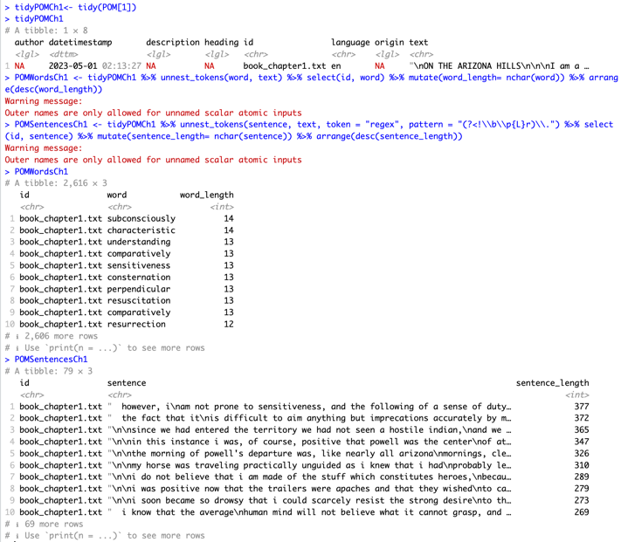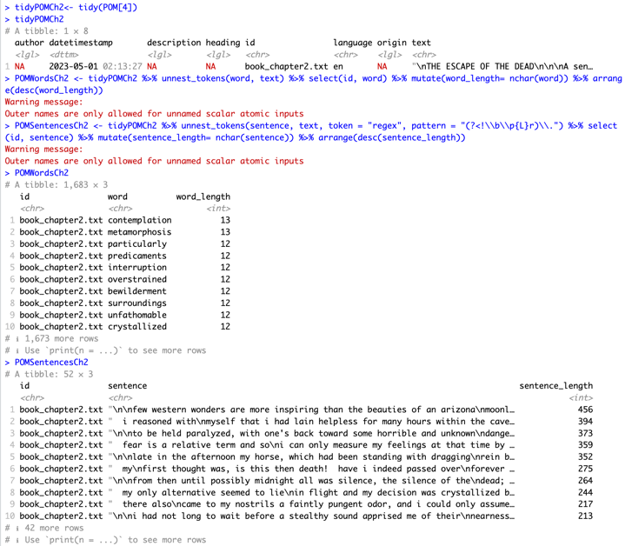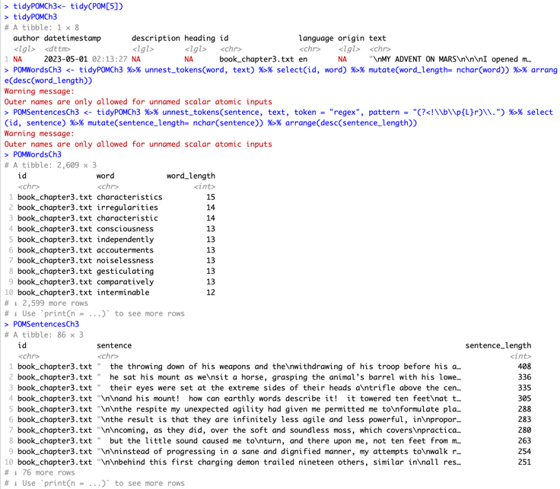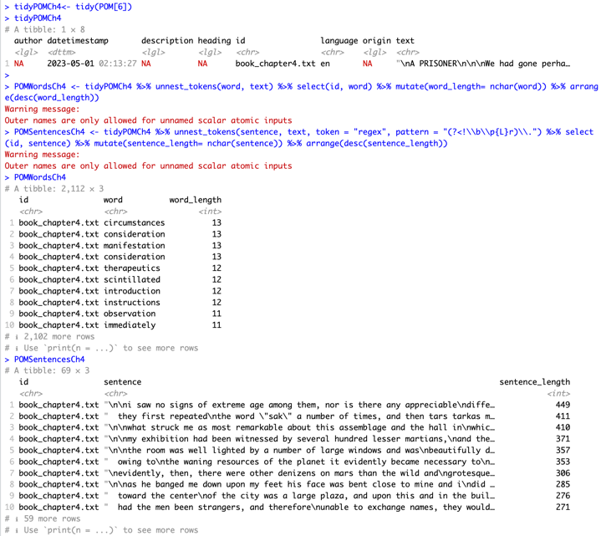

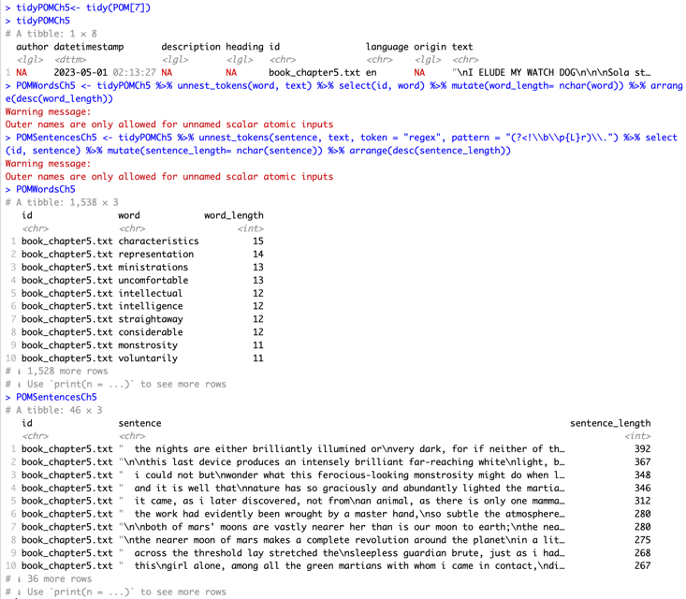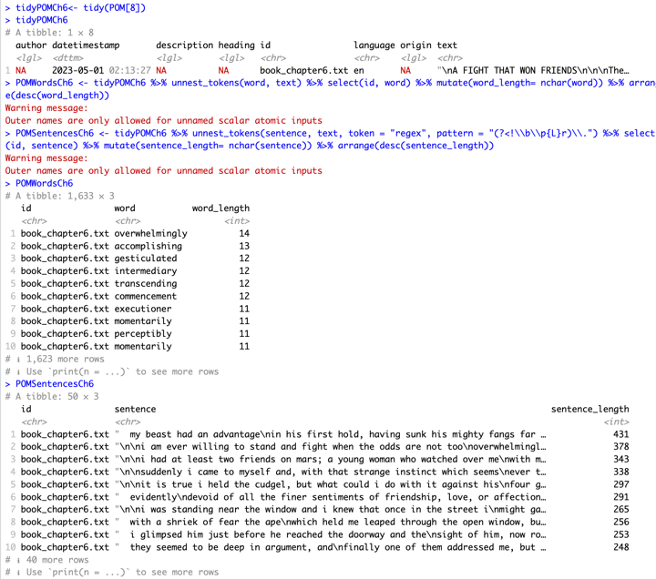

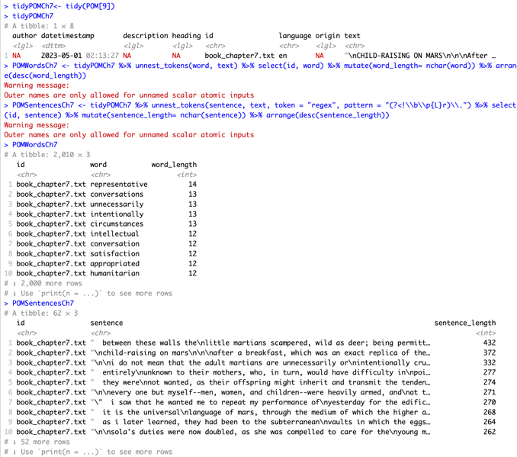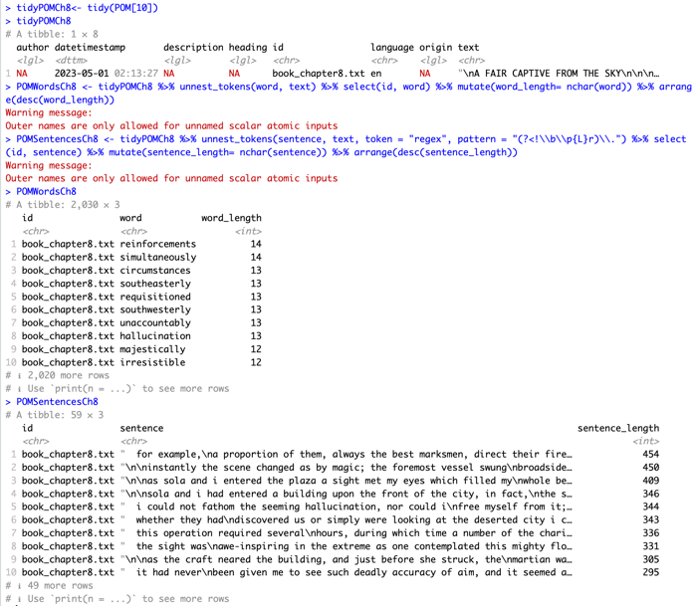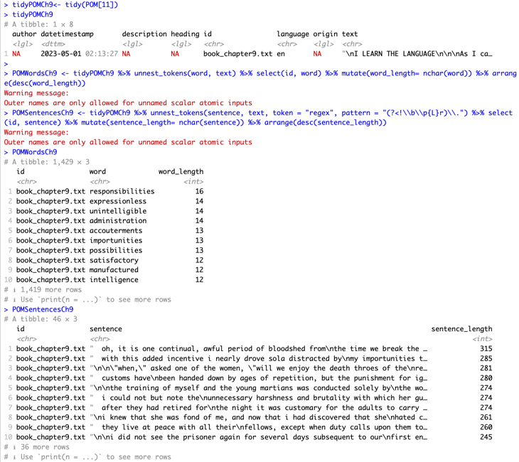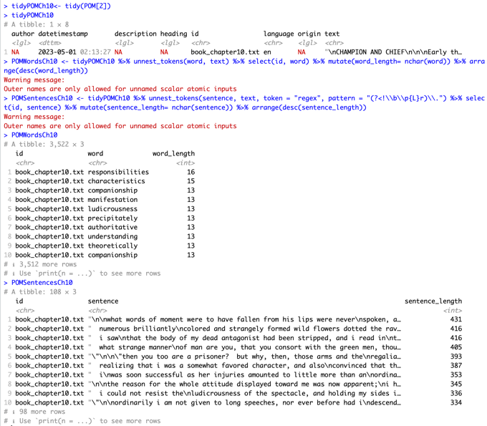

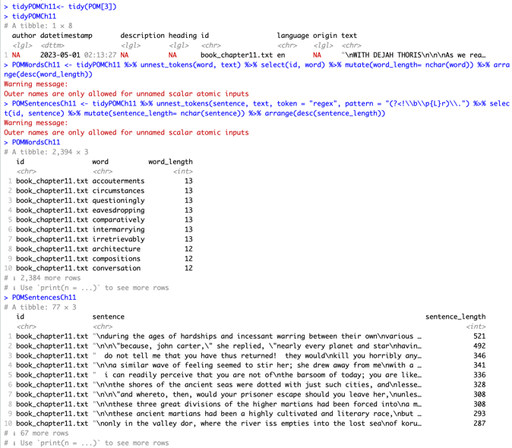

**5. Corpus Cleansing/ Data Wrangling**

Next, we proceed to clean our data by removing stop words, numbers, and punctuation. Our document is already in lower case. We start by removing quotes from our corpus, and employ gsub() to do so.



We then define a function “removeNumPunct()” to remove numbers and punctuation. The POM corpus can then be passed to this function to generate our clean corpus “POMcl” as shown below.

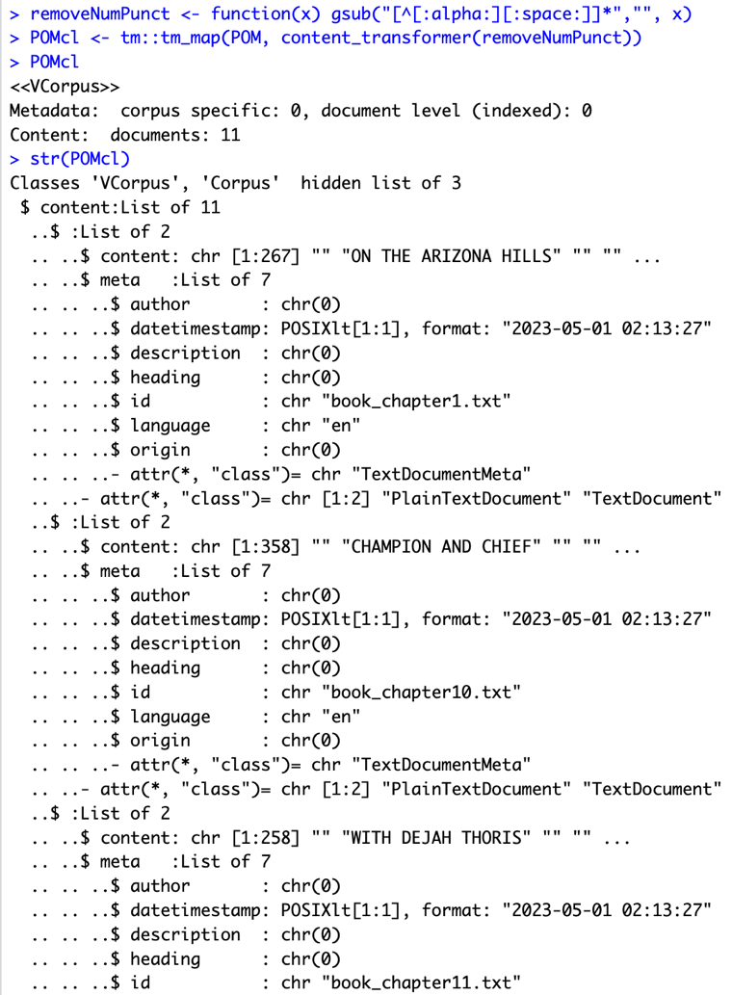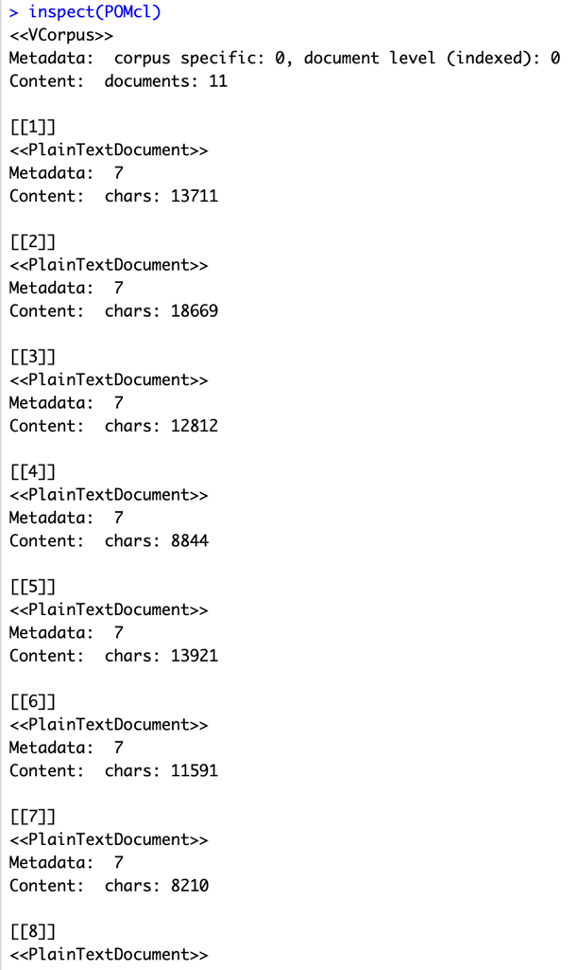

If we inspect our clean corpus, we can notice that we removed 246, 436, 335, 155, 267, 236, 170, 186, 206, 199, and 146 characters from our respective documents representing the chapters. We can make sure our clean corpus is in lowercase by passing it to the tm_map() function.

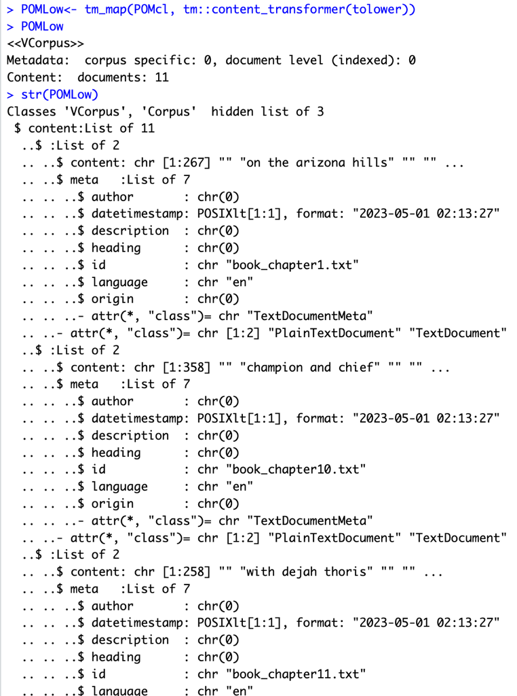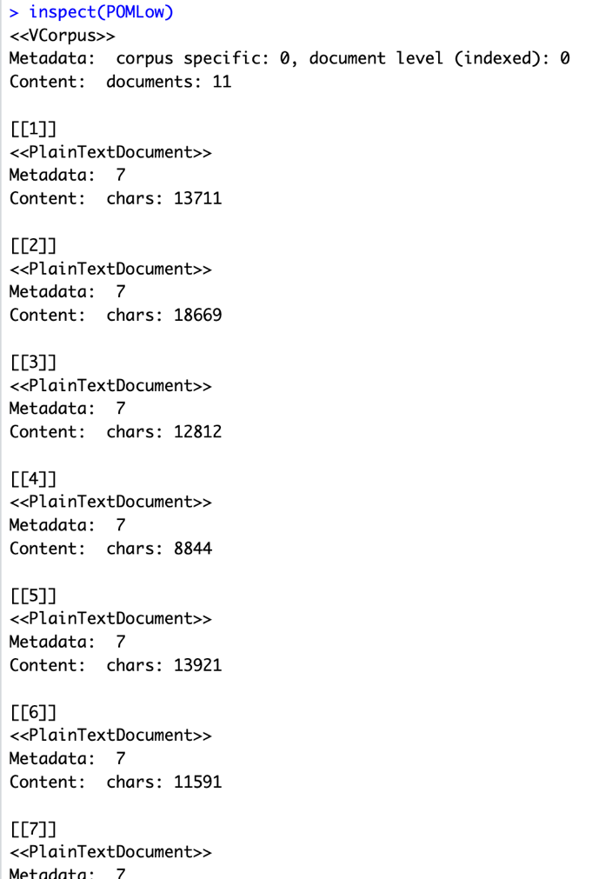

Now, we have the same number of characters, the punctuation, numbers and quotes have been removed, and everything is in lower case. Following the rubric, we proceed to compute the Document Term Matrix of the clean corpus.

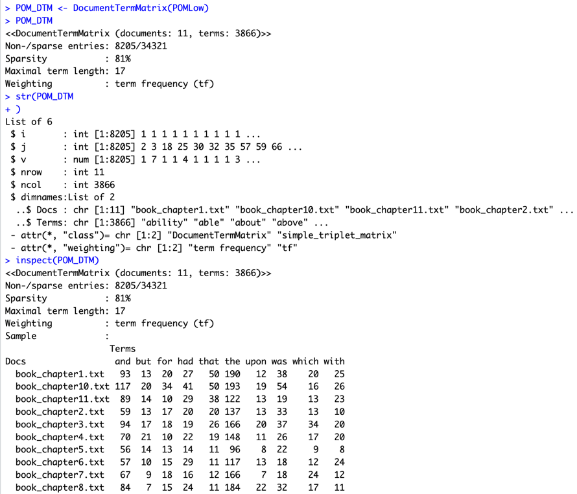

We notice our sparsity has reduced by 2% to 81%. However, this is till very high and we will employ techniques to further reduce it. Sparsity indicates the number of 0s in our Document Term Matrix. The high sparsity in our corpus can be visualized by viewing our DTM using the as.matrix(POM_DTM) method. We can observe a lot of 0s here, confirming the 81% sparsity.

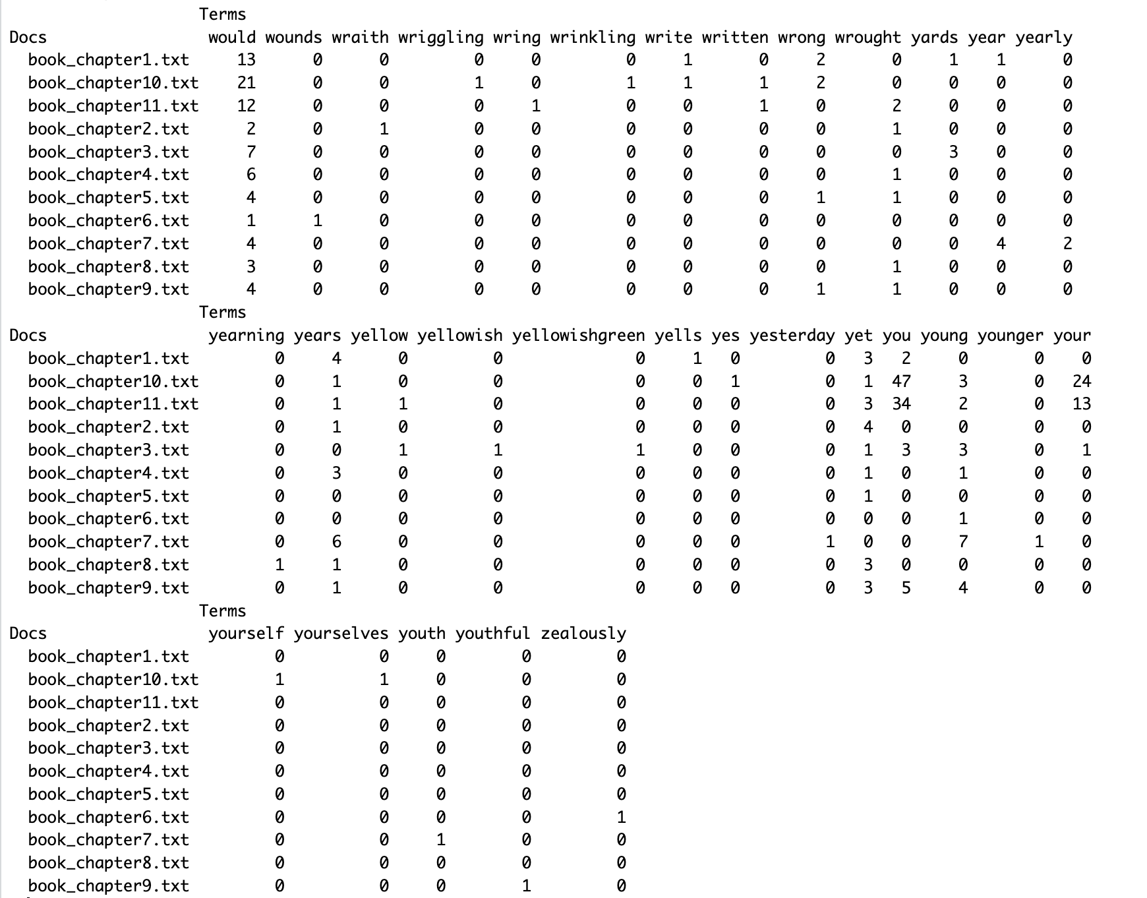

Next we remove the stop words from our DTM.

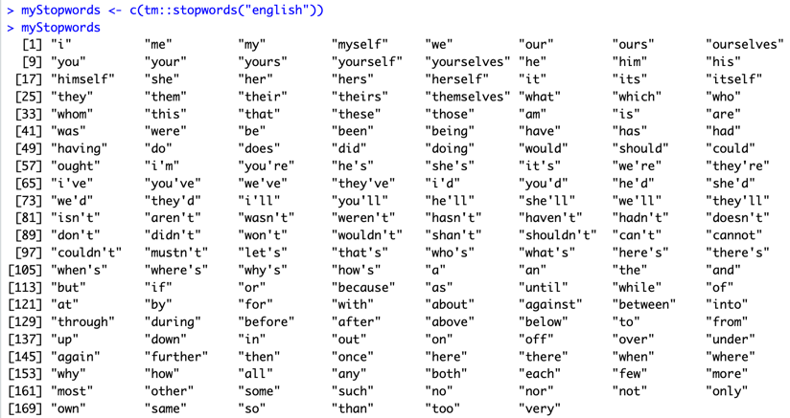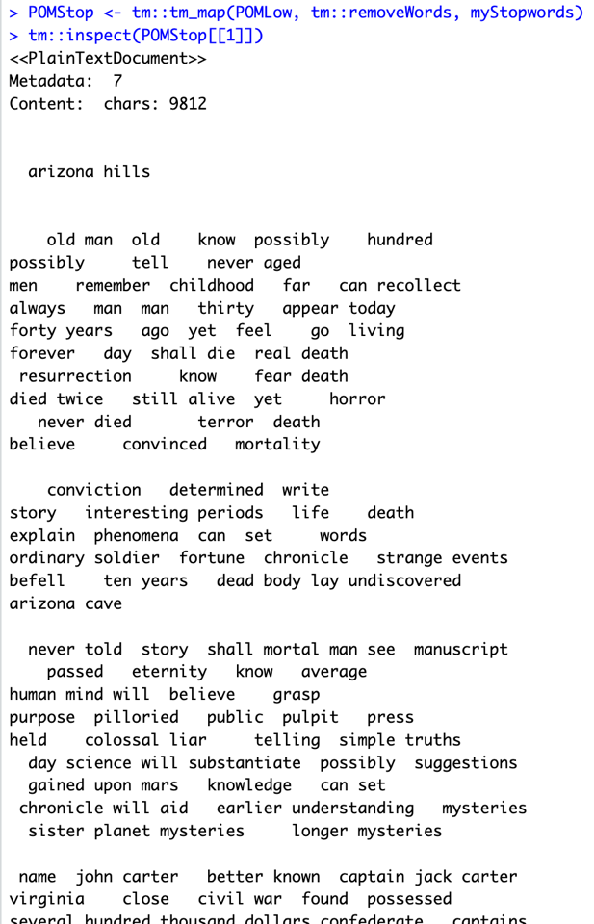

Here we have removed several stop words using the tm package and can inspect the first document to get a sense of what our corpus looks like. As we can see, the stop words have been removed and our corpus can be analyzed better.

Now that the stop words have been removed, we create the Term Document Matrix again. We also apply findFreqTerms with a lowFreq of 5.

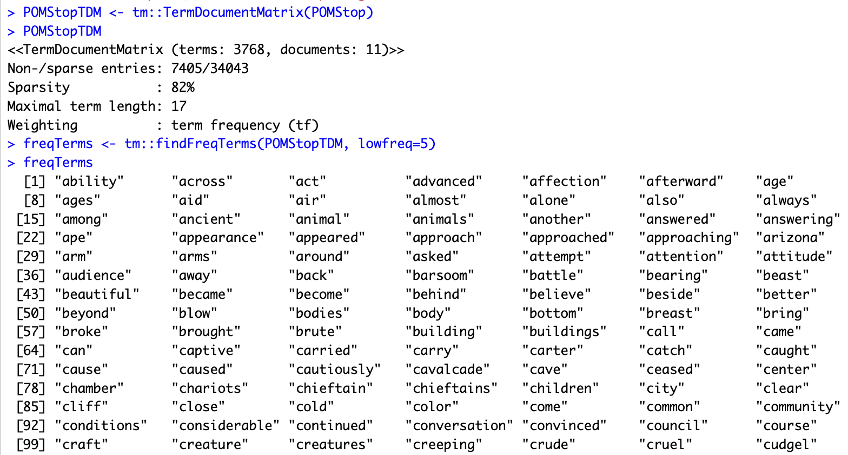

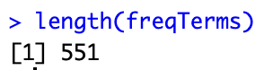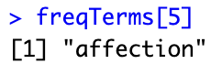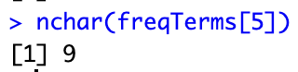

We check the number of our freqTerms which is 551 and can check specific frequent terms. For example, as shown the fifth term above has a length of 9. We can compute the term frequencies for each document as follows. Later on we will unlist tfList and combine all the term frequencies.

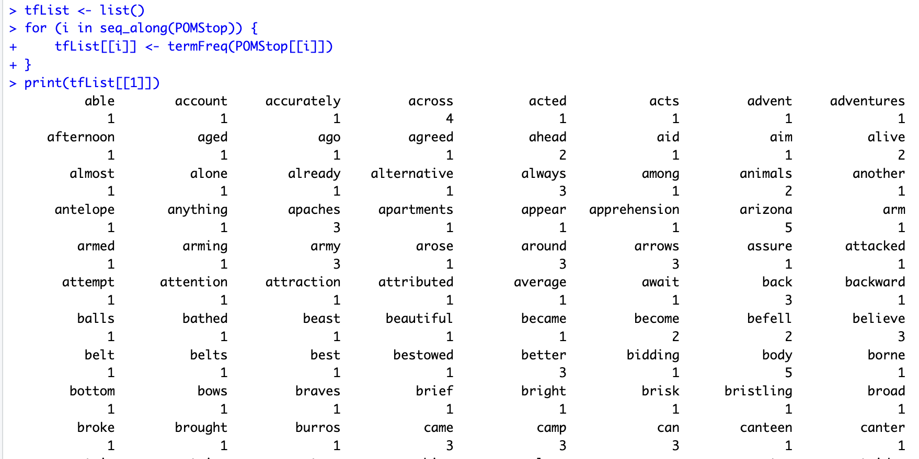

We can inspect POMStopTDM again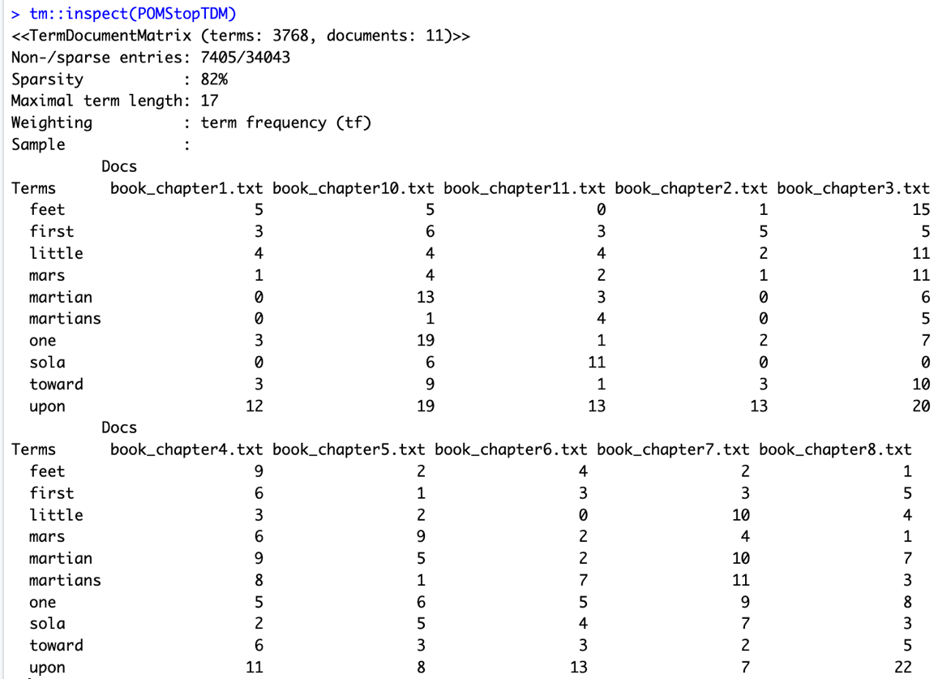

**5. Dendrogram and Word Cloud**

Next, we can draw a dendrogram for POMStopTDM.

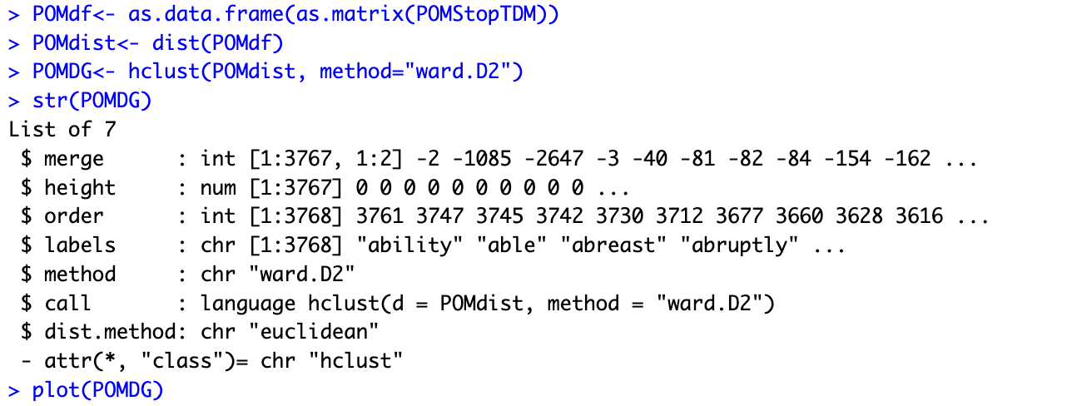

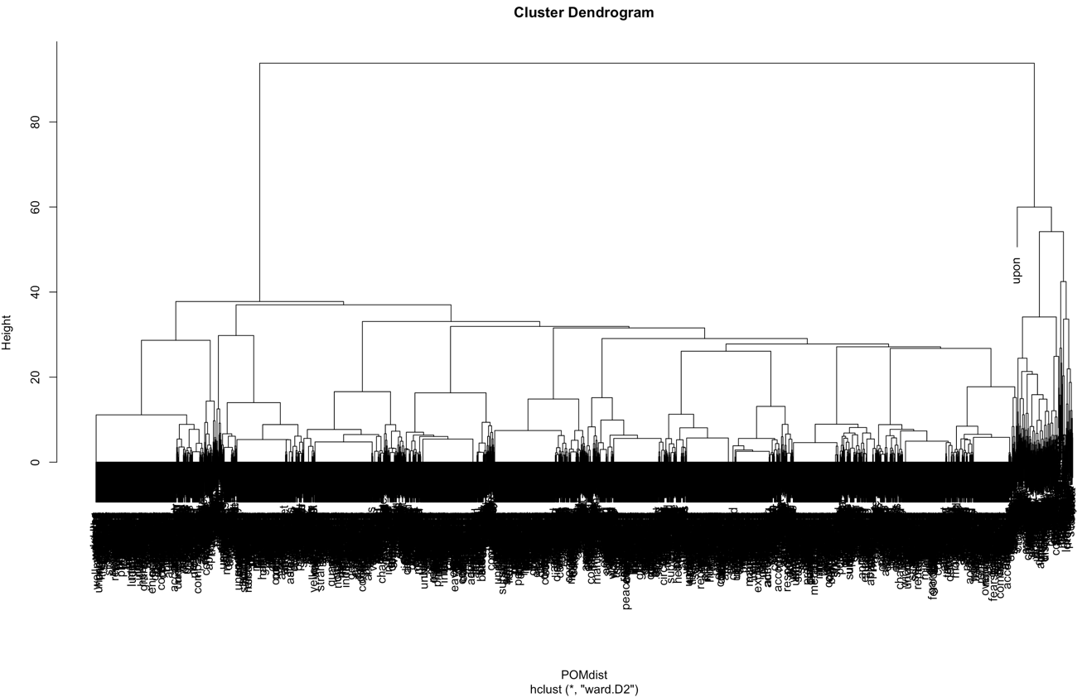

We can observe that we have many labels, and it is hard to analyze our dendrogram. Therefore, it would be helpful to remove some of the sparse terms to get a good dendrogram. We utilized the removeSparseTerms() function from the tm package to remove the sparse terms from the term document matrix. We experimented with different values for maximal allowed sparsity and found that a value of 0.4 yields us a comprehensive dendrogram that can be analyzed. We get a sparsity of 24%. (We did not prefer reducing the sparsity to 0% as that would lose a great percentage of the terms and we want as many relevant terms as possible for our analysis).

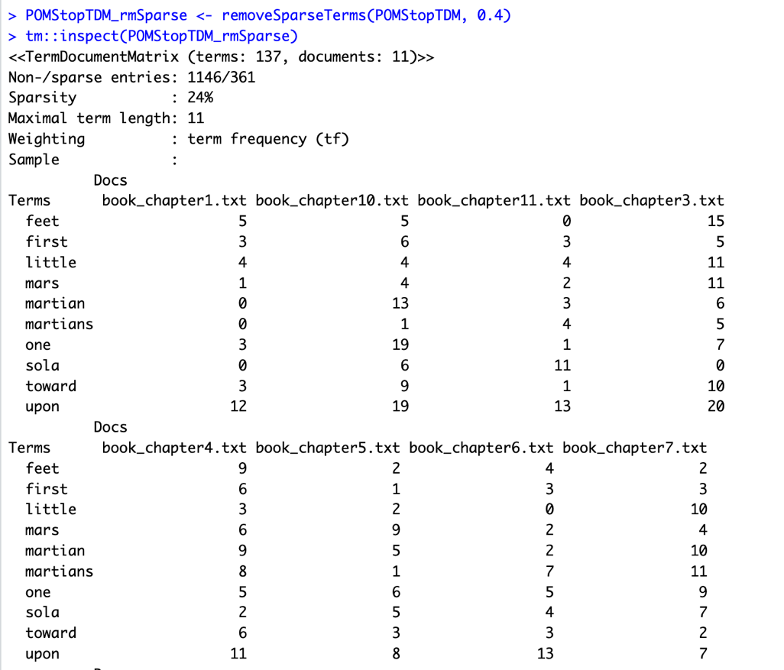

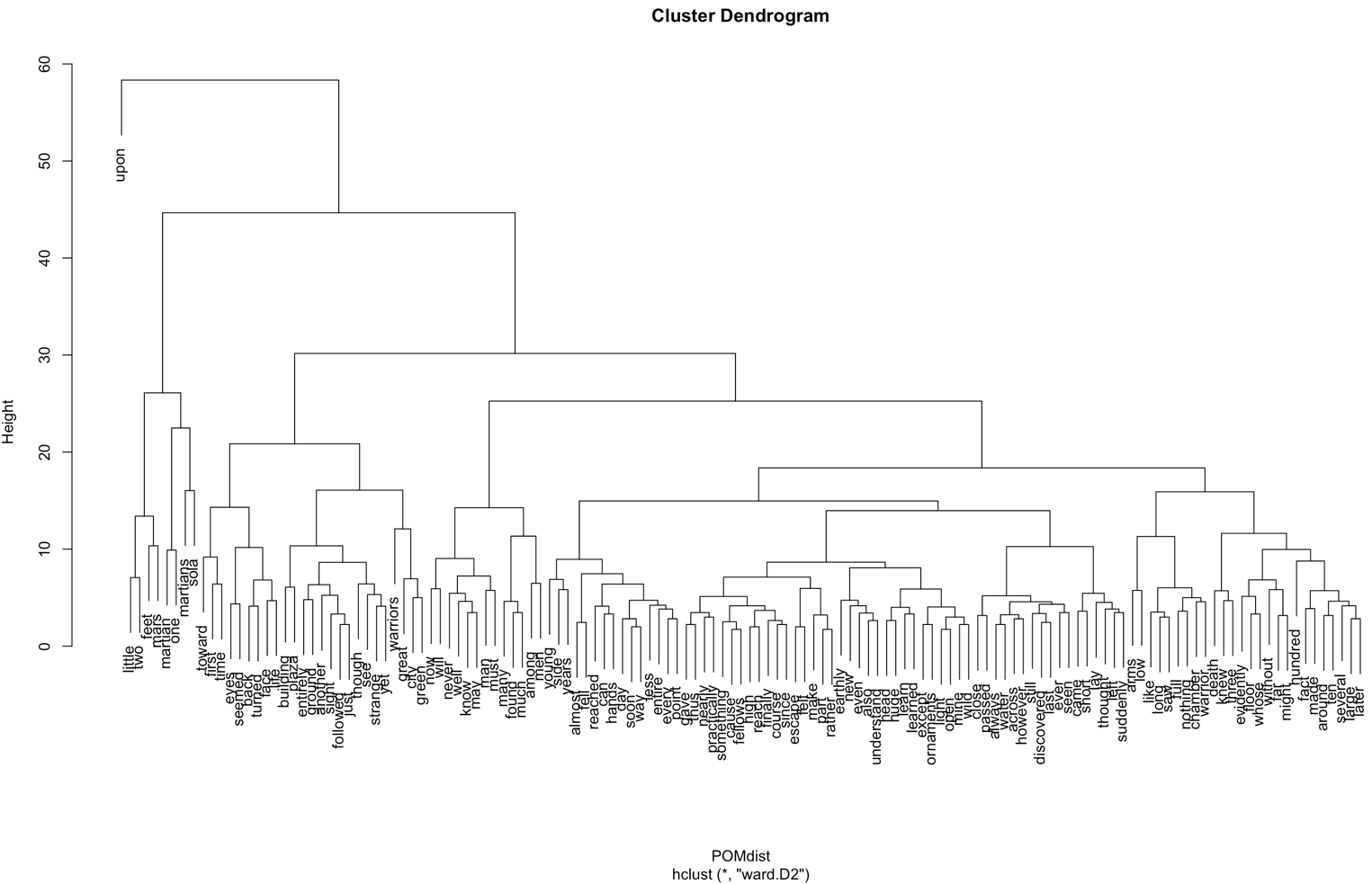

We can now proceed to generate a word cloud. We use the wordcloud package for this, install it, and make it a library.

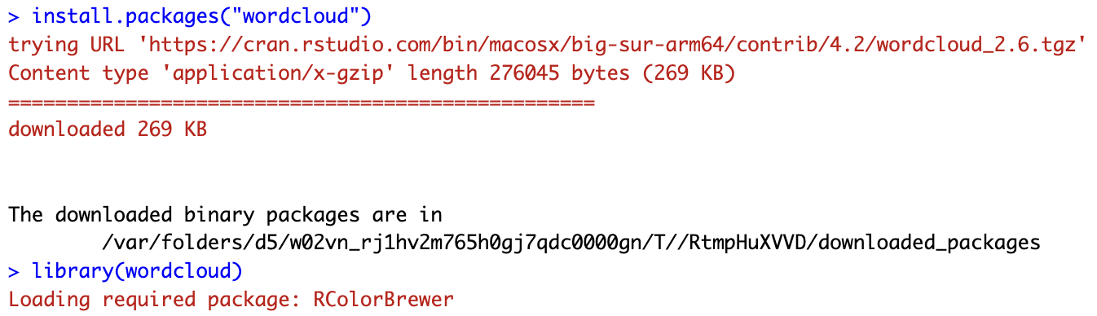

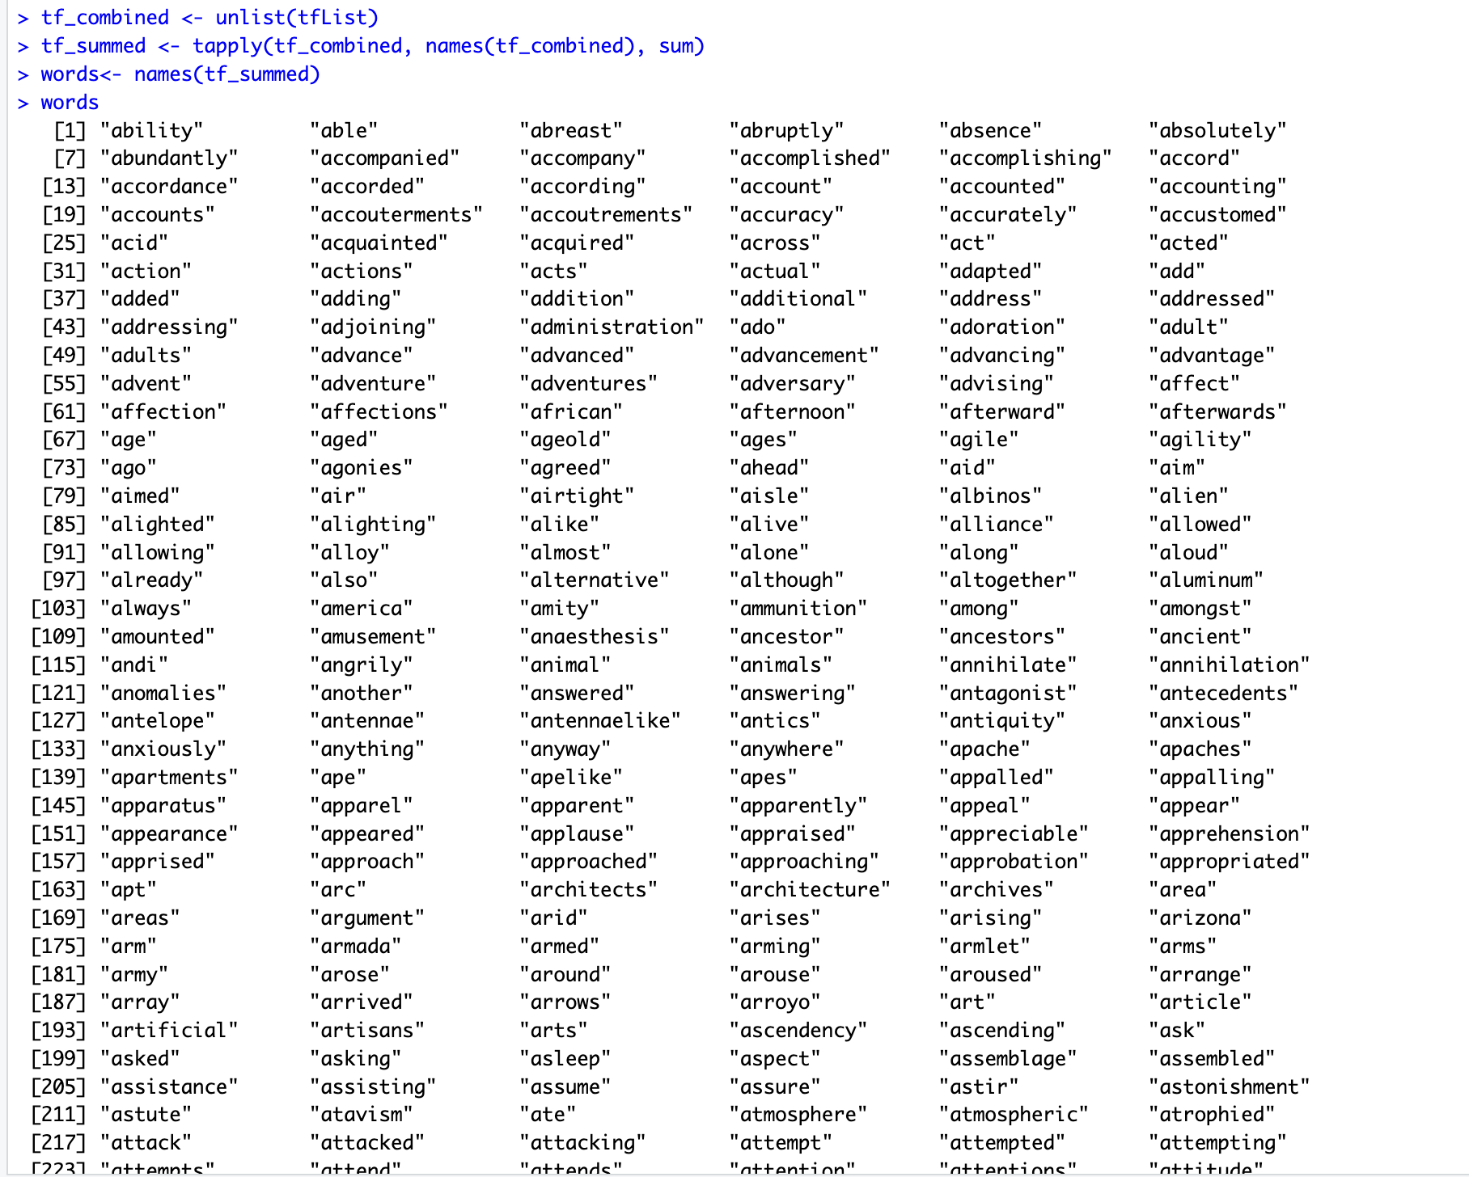

Here we extract the unique words using the term frequencies for all the 11 documents. We unlist the tfList variable to combine all the term frequencies, then we sum up the term frequencies for each unique term. And then we obtain the set of words into the **words** variable.

Next, we generate the wordcloud using the wordcloud() function. We pass the summed term frequencies and the words to generate it. Some warnings occurred and upon examining them, we found out that some words were too long to fit in the wordcloud and were thus omitted. To tackle this, we generate another wordcloud, keeping min.freq = 10 to only display words that appear at least 10 times in the corpus.

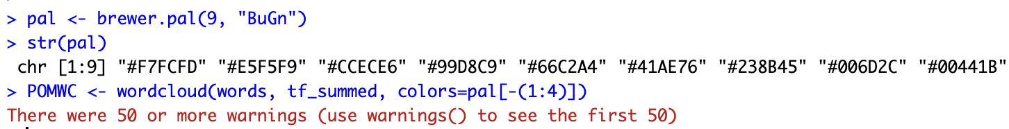



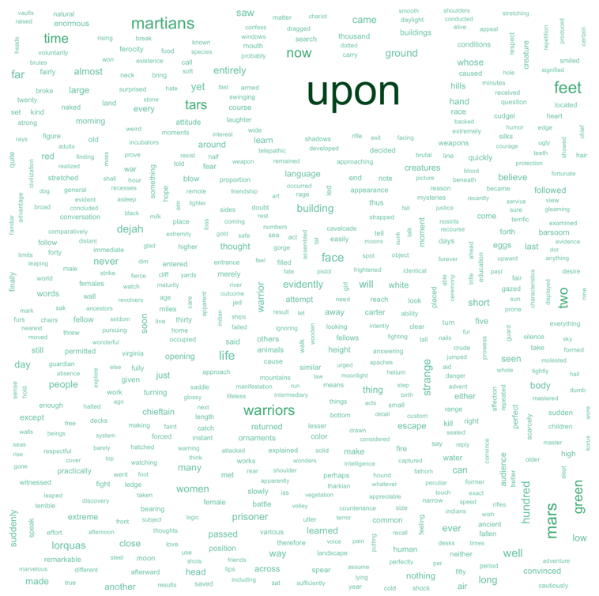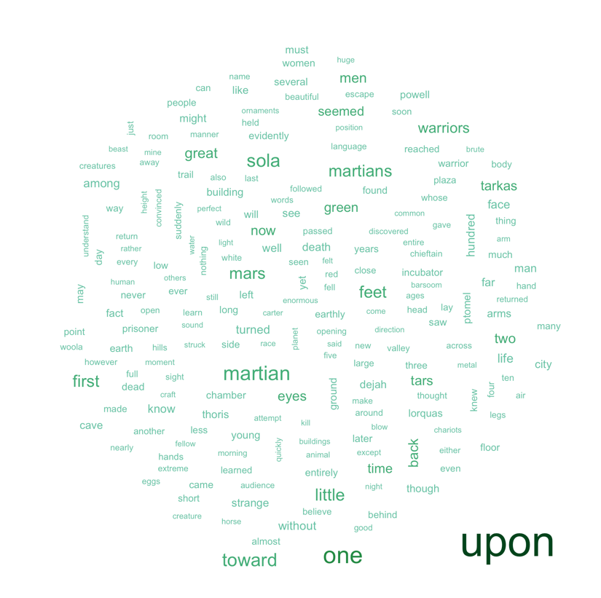

The second word cloud helps us understand the word cloud a bit better.

**5. Applying functions from packages to the Corpus**

Following the rubric, we go through several packages like “quanteda”, “syuzhet”, etc. to perform further analysis.

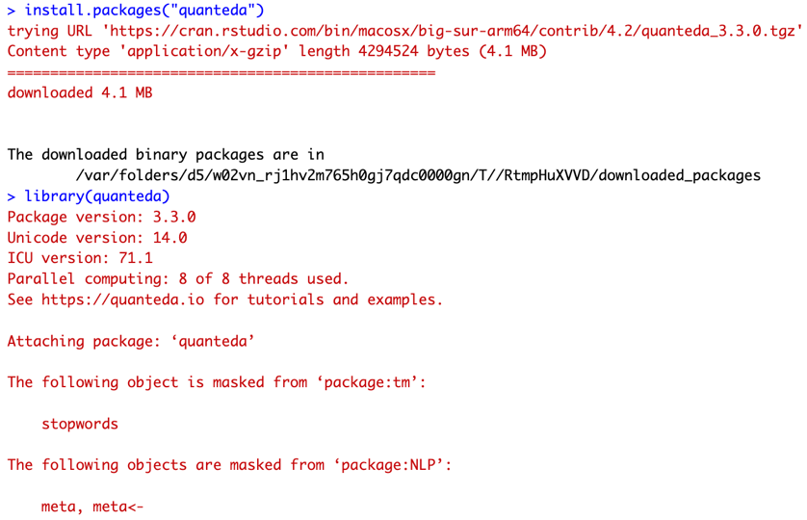

We use the clean copy of POMcl to perform further analysis. Printing out the first few lines of the first document:

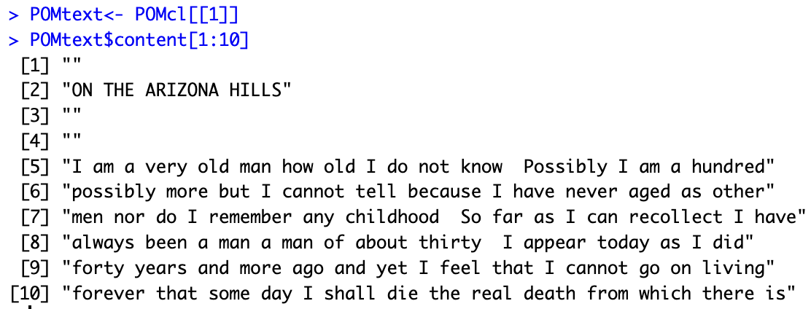

Let us apply a few methods from the quanteda package on our corpus. Kwic() helps locate keywords in context from the text.

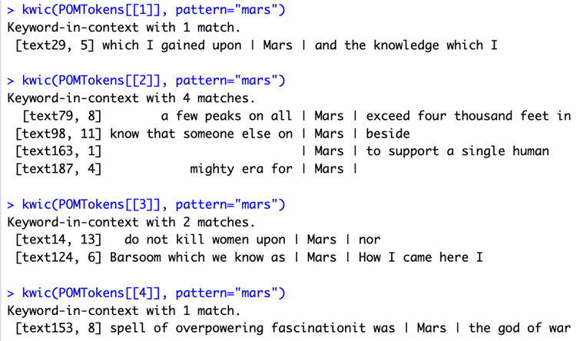

Next we apply tokenization. We do this by using the lapply() function to apply tokenization to each of the 11 documents of the corpus.



If we examine the structure of POMTokens using str(), we see a huge output for all the eleven documents.

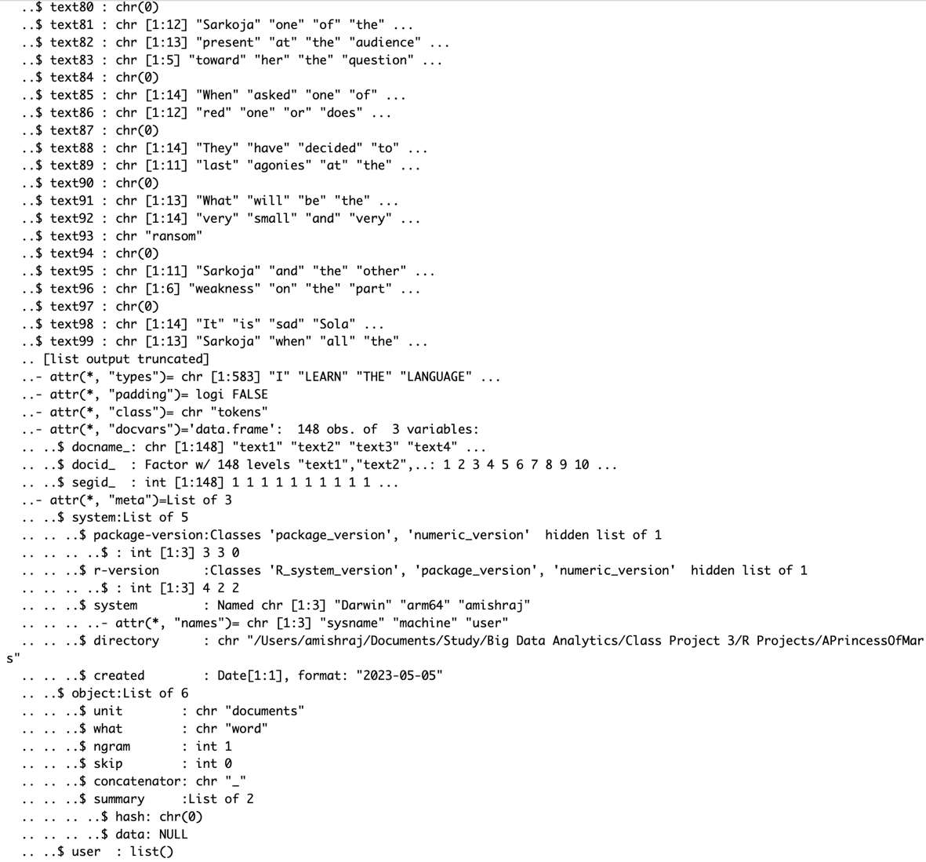

We now use the dfm() function to create sparse document-feature matrices for all the chapters. Here, we also remove the stopwords using dfm_remove()

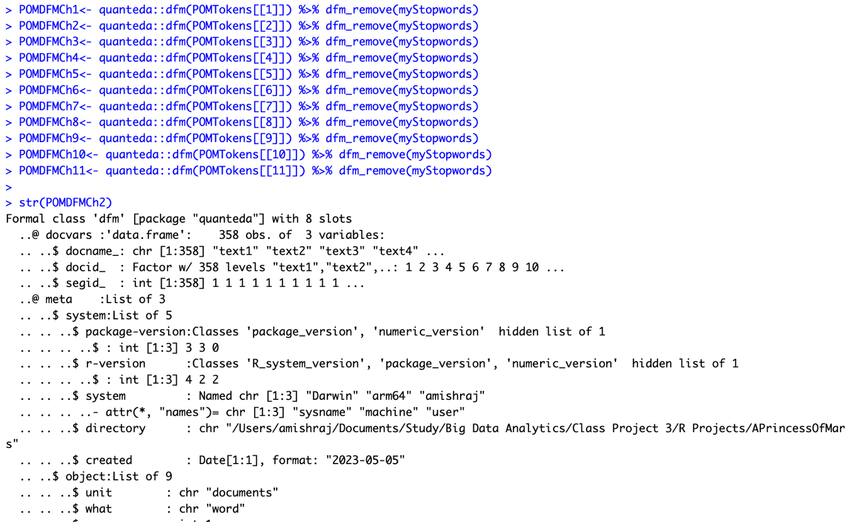

Next we get the frequency of terms in the DFM for the chapters.

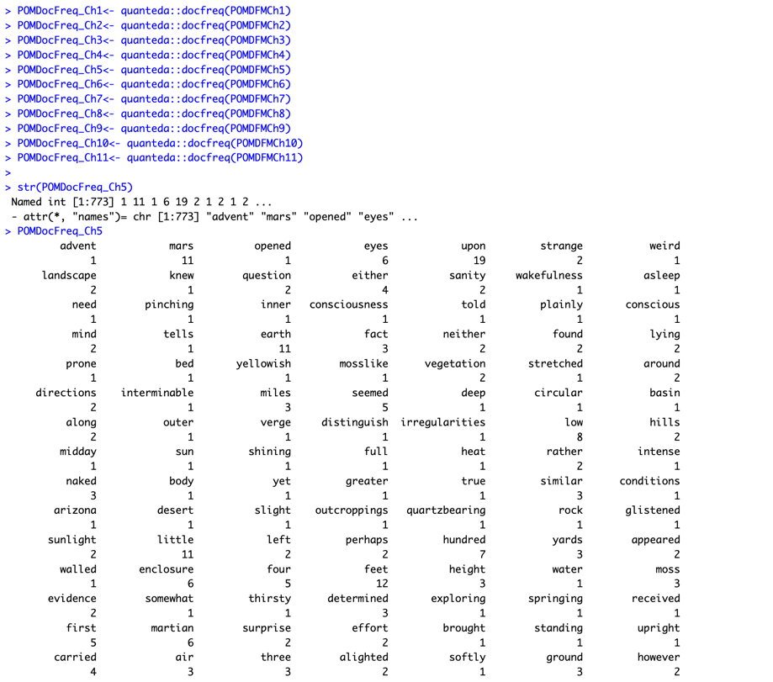

We now assign weights to these words.

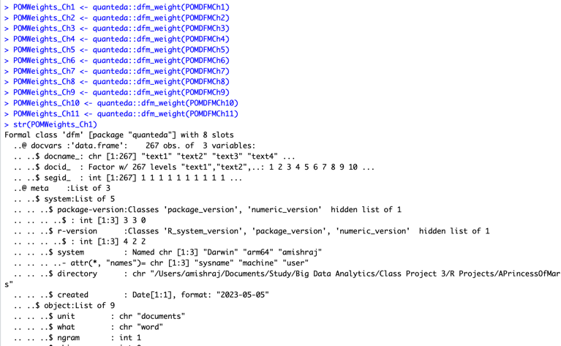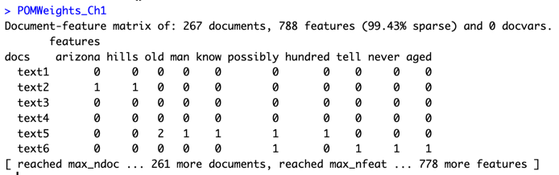

Now we compute the tf-idf score. This helps us weigh a dfm by term frequency-inverse document frequency (tf-idf), with full control over options.

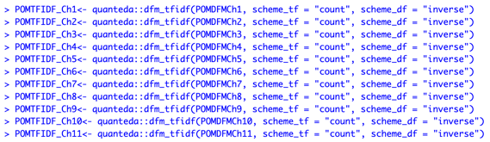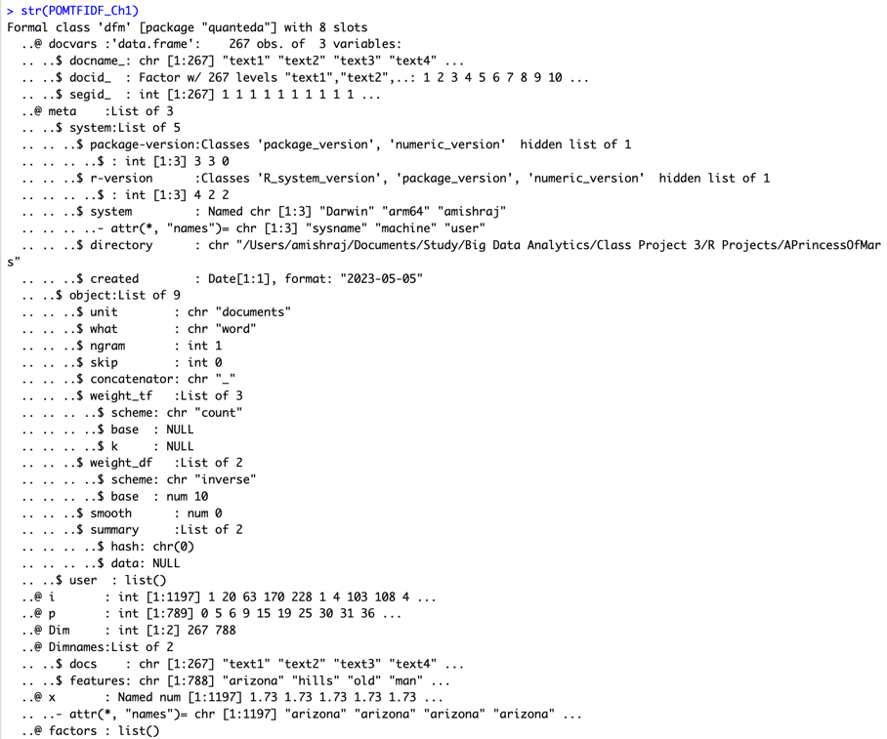

Now we install the “syuzhet” package and make it a library.

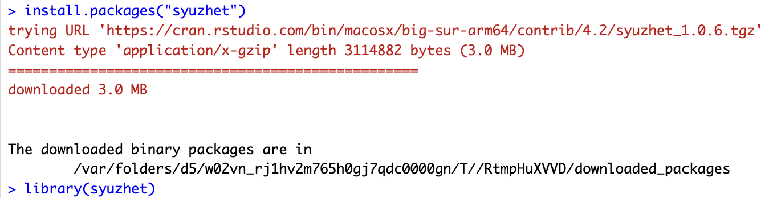

We can extract text as a data frame. Let us apply a few functions from the syuzhet package on our document.

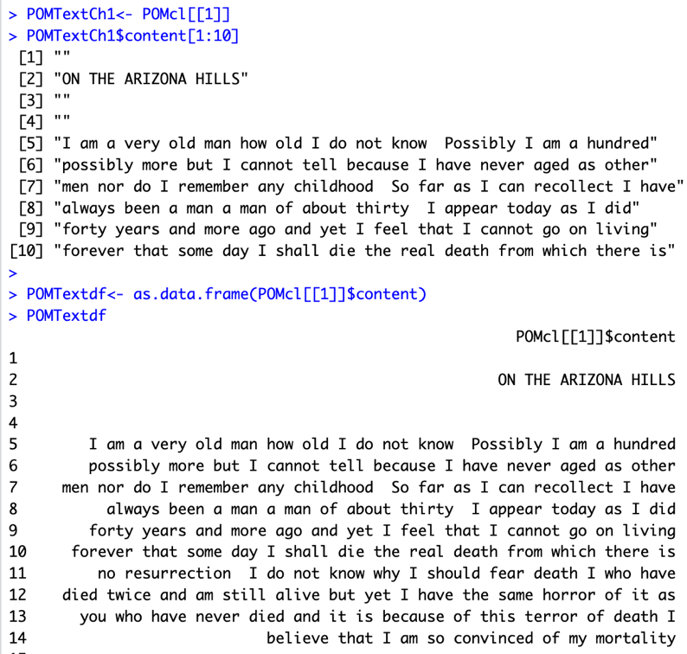

To get the sentences in APrincessOfMars.txt, we first read the file as one large string as shown with the help of get_text_as_string() function.

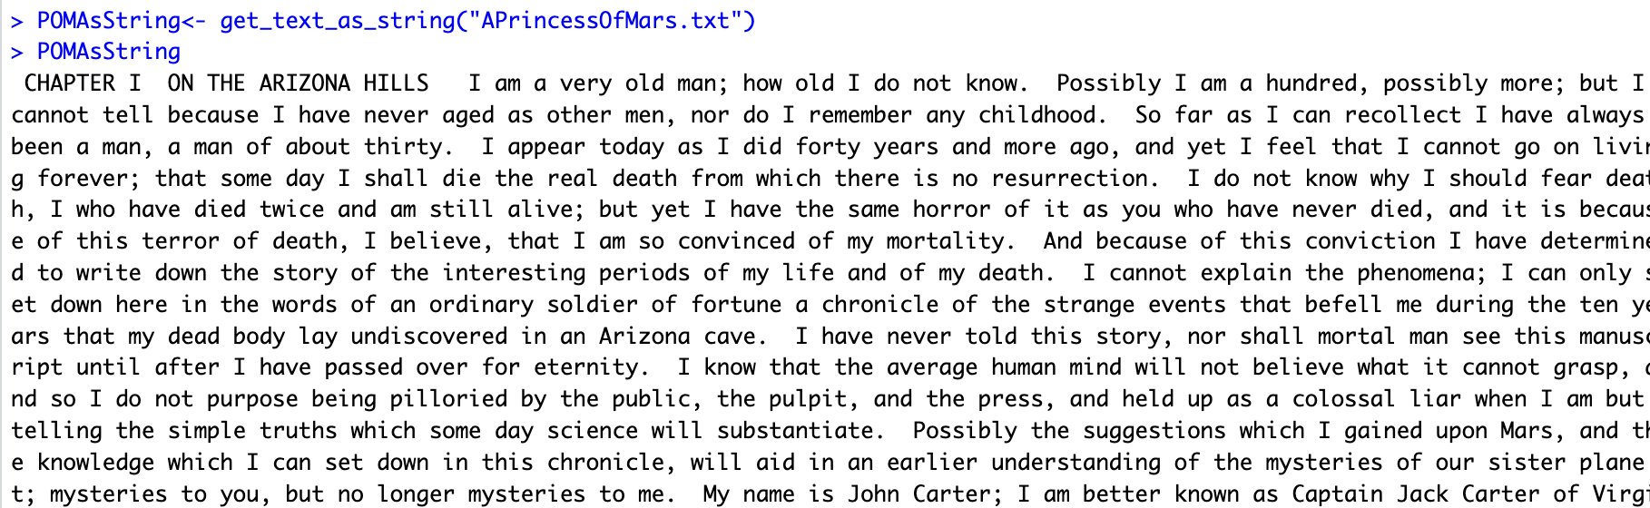

Now we get the sentences using the get_sentences() function from the syuzhet package. It parses the string into individual sentences.

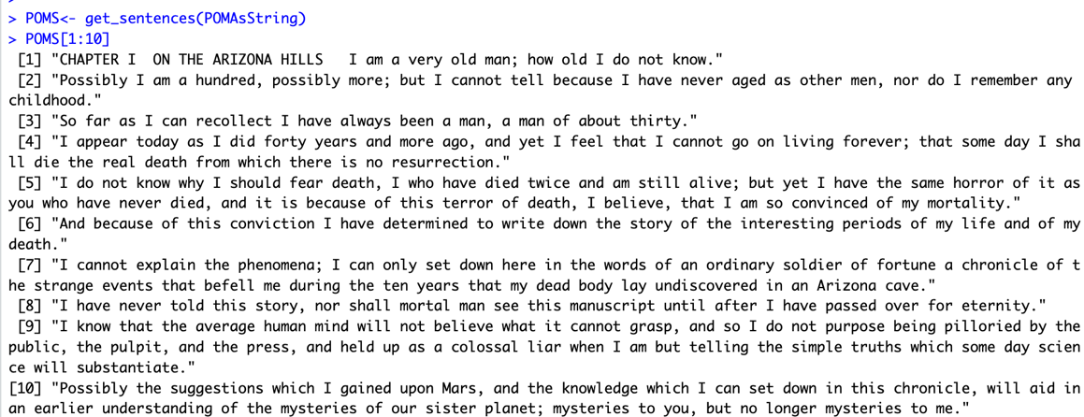

We now proceed to extract the sentiments from these sentences. To do this, we utilize the get_sentiment() method that takes a vector of strings and one of four methods for sentiment extraction, "syuzhet", "bing", "afinn", and "nrc". We experiment with all of these methods to observe the results. POMS is a character vector.



We first call get_sentiment() with the default value of “syuzhet”

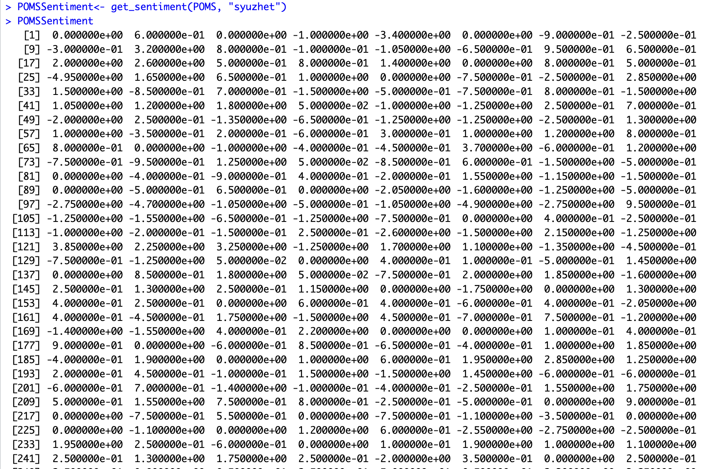

If we try the “bing” method, we get the following results.

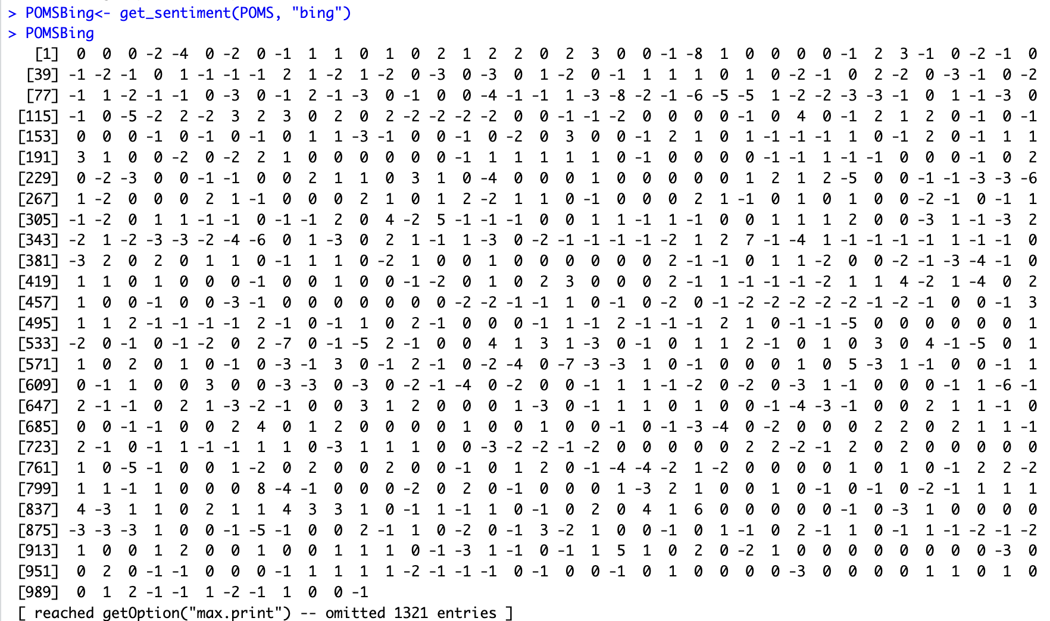

For “afinn” we get the following results.

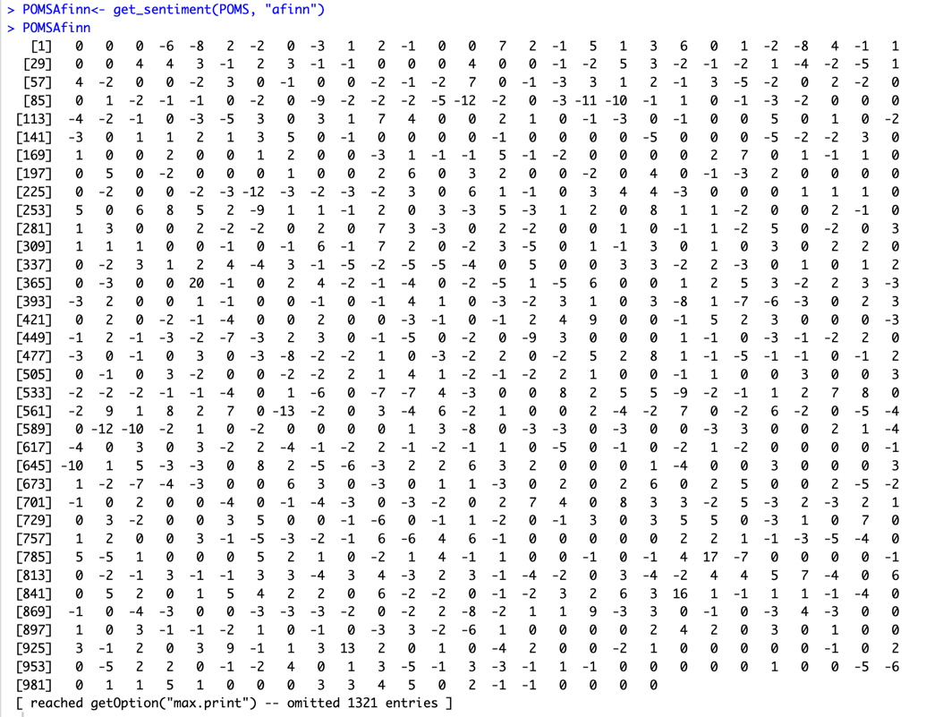

Lastly, for “nrc”, we get the following results.

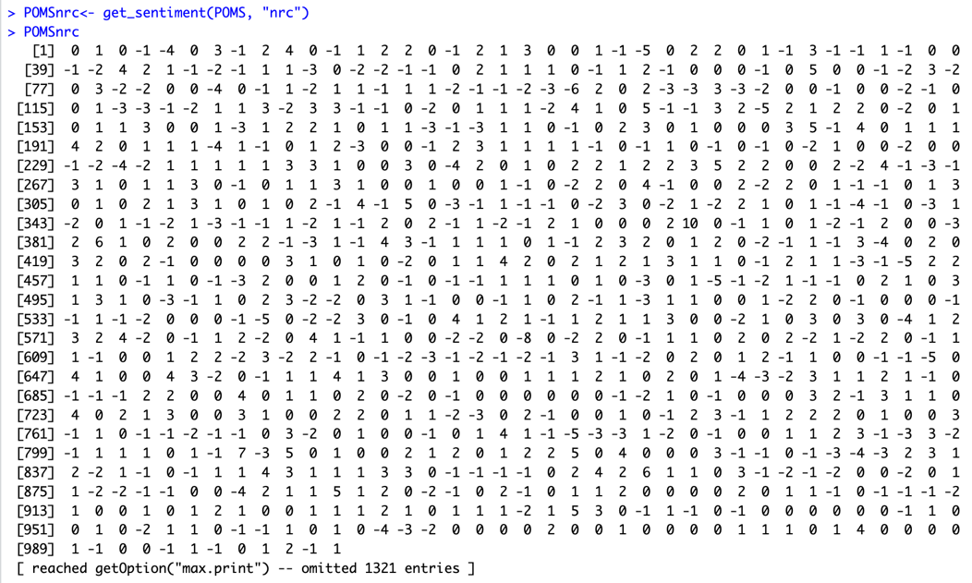

Let us look at the sentiment dictionaries for these four methods.

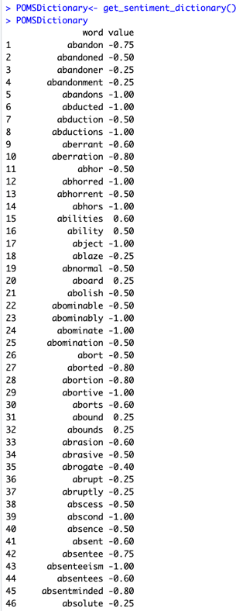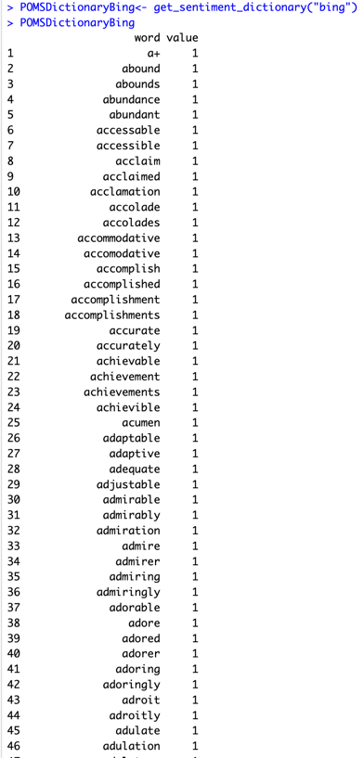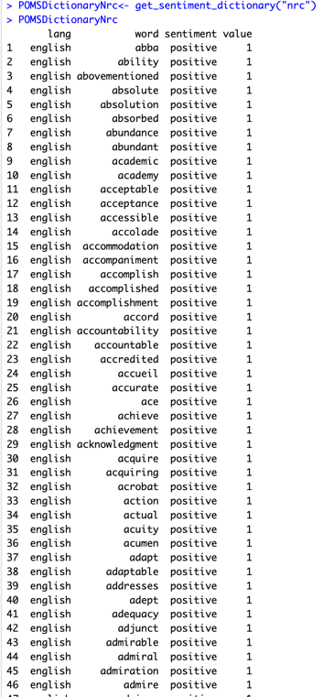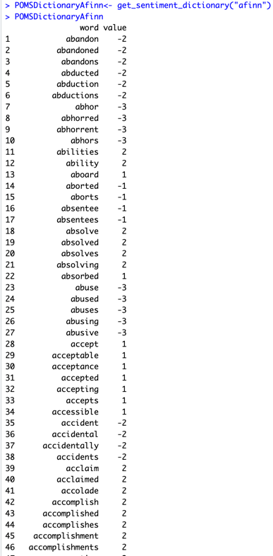

We can notice that each of these methods have different criteria and rules that assign sentiment to words, and their dictionaries have different lengths.

Let us sum the values of the sentiment vectors in order to get a measure of the overall emotional valence in the text:

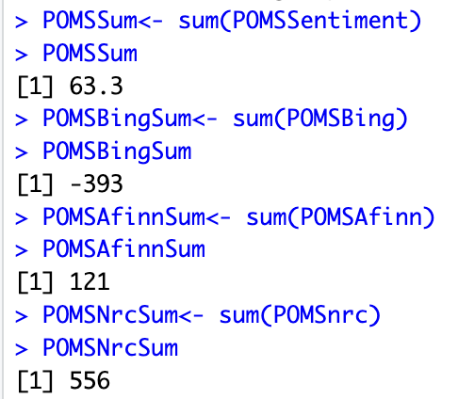

We can observe that except Bing, the other methods say that the content of the text is positive. Bing on the other hand, gives a very strong negative number for the sentiment. To do sentiment analysis, it is important to understand the basis of the sentiment dictionary we use. Since A Princess of Mars is a book, it would be best to use syuzhet as it was designed for analyzing literary texts.

We can then examine the summary() results of the sentiments generated from these dictionaries to understand the distribution of sentiment.

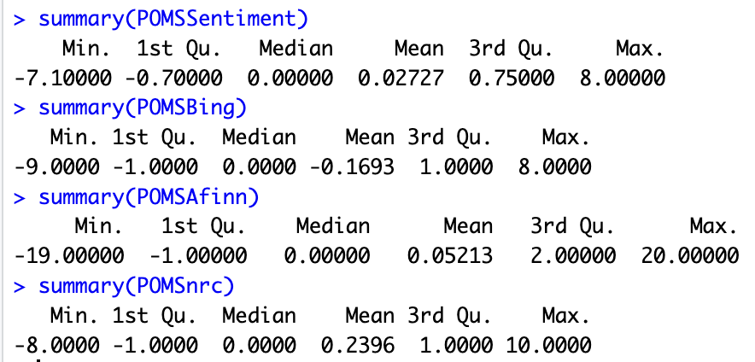

The mean sentiment in general, appears to be more neutral. The first half seems to be more negative than the second half. However, to further understand how the sentiment of text changes from the beginning of the text till the end, let us plot the values.

Syuzhet:



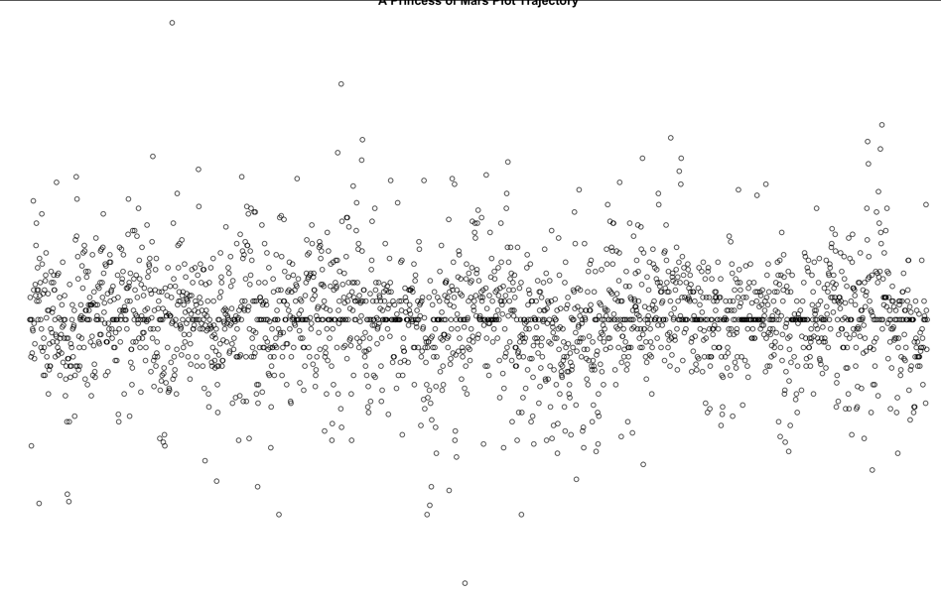

Bing:



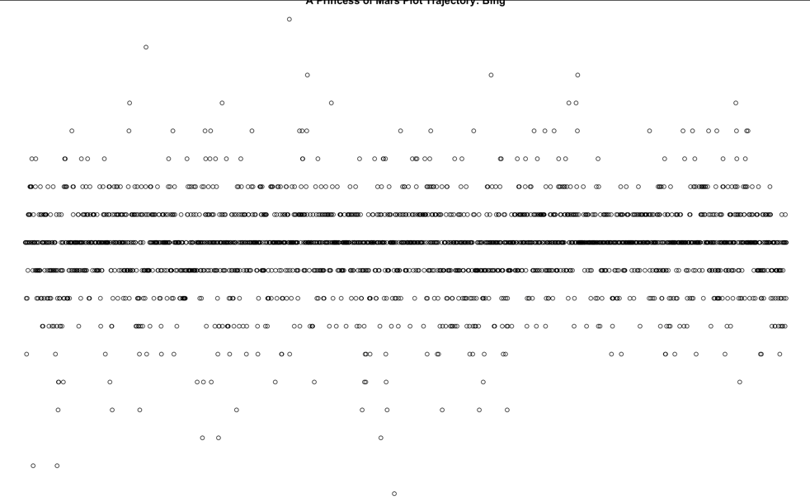

Afinn:



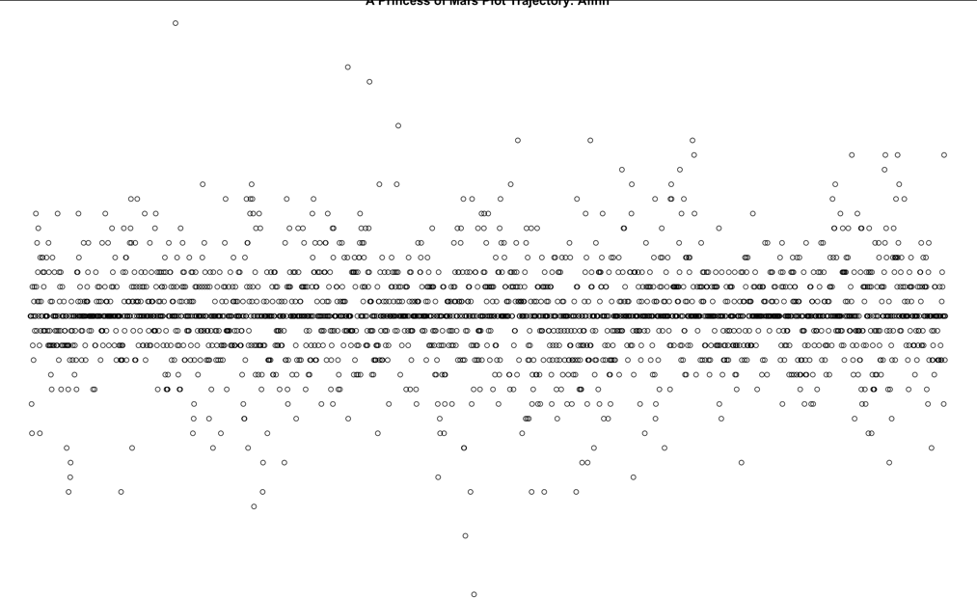

NRC:



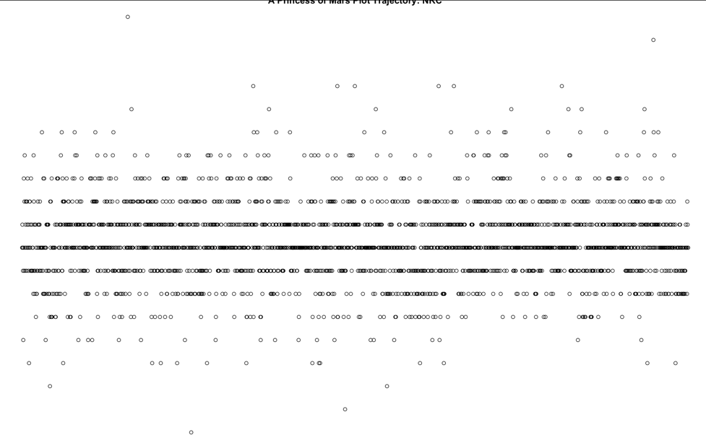

Let us now use the get_percentage_values() function from the syuzhet package to compare the shape of one trajectory to another. We have plotted values for 10, 20 and 50 bins respectively.

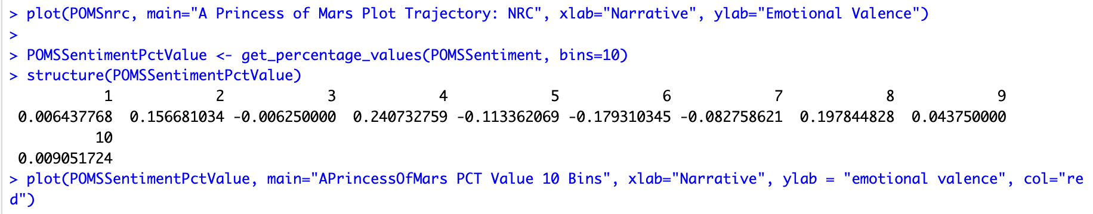

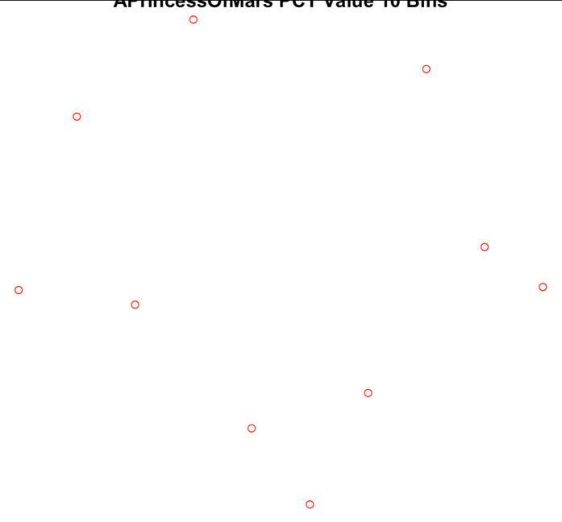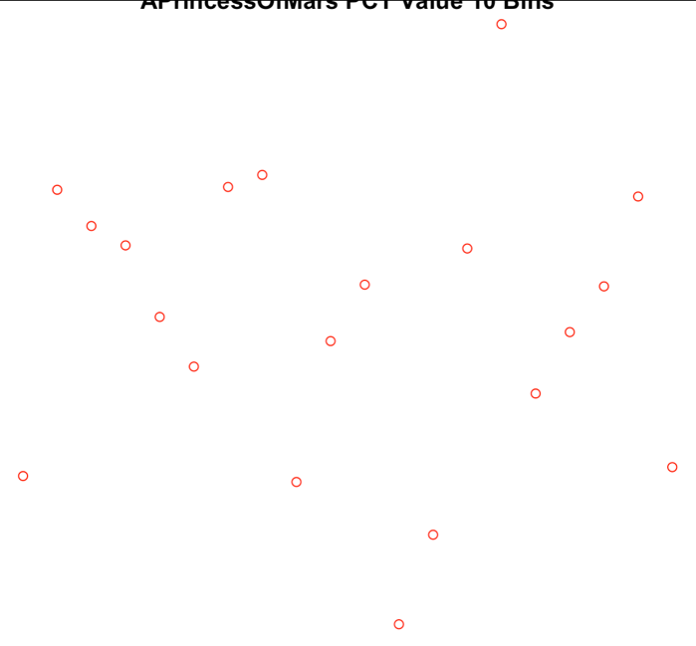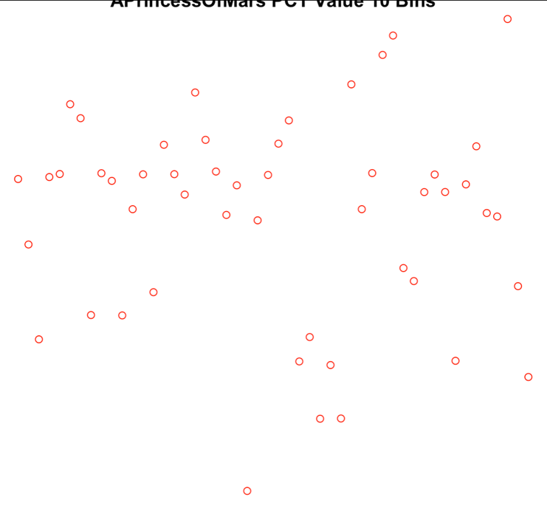

Through these plots, we understand that the sentiment shifts a lot throughout the text, from being very high in the beginning, to low in the middle, and high again towards the end. This can imply volatile and more emotional content in the book. The large number of sentences, prominent words in the word cloud such as martian, creature, incubator, spear, plateau, city, warriors etc. hint towards a science-fiction themed text with violent acts being performed throughout, further hinted by the volatile sentiments. However, further analysis may be required to understand the text on a deeper level.

**6. Discussion**

This project helped us gain practical hands-on experience with Text Analytics. Following the rubric, we had a path to follow for this project, yet the challenges along the way, such as dealing with multiple documents, or accommodating large text, reducing sparsity etc. are all concepts we learned while trying to solve a problem. For the same reason, we also understood why Data Science is an empirical science. We learned about data preprocessing, and how cleaning the data before perfoming the analysis is of such a high importance, because stopwords, punctuation, quote marks etc. are all things that do not contribute to the analysis and thus, need to remove as keeping them could skew the analysis we are trying to perform. We learned various packages for Text Analytics and the interesting capabilities they support, including creating wordclouds, retrieving information about the text, assigning sentiments etc. Through all these bits and pieces of analysis, in the end we are able to gain a somewhat rough image of the text we are looking at.

The Text Analytics project was a great learning experience and as the third project, accumulated up the knowledge we gained from the previous projects. It helped solidify approaches, thought process and troubleshooting for analytics. It also proved yet again the convenience R brings to the table when it comes to performing high quality comprehensive data analytics.

To summarize, after the completion of this project, we are confident in working with R, performing text analytics on large datasets, cleaning data, extracting useful information, generating plots, wordclouds, understanding sentiments, applying different functions and measures/metrics on the documents that lets us draw different inferences about the problem domain i.e. the text, along with simplifying text for better analysis.